Peek into Pink Party

Director/Recruiter:
Introduce yourself, ask welcome guests and “drop ‘live’ in the comments below if you’re watching live, or ‘replay’ if you’re catching us later.” – Welcome new consultant and introduce her.
We are here to celebrate _________ as she starts her Mary Kay business. Y’all post in the comments below why you think _________ will be so amazing at Mary Kay. I think _________ is going to be great because ____________________.

Interview style: new Consultant answers these questions:
Why are you so excited about MK?
How will it impact your family?
What kind of experience are you looking to provide for your clients?
Director/Recruiter:
I know you all would love to support _________ with her new business…and we’re going to explain how in just a few. But first…what are you looking for from a small business? Is it personalized service? Gift Wrapping? Discounted Shipping? Let us know in the comments below – because YOU get to help _________ create her business plan.
Now let’s check out some of our favorite MK products that _________ can share with you –

QVC style or you can demo the products on your face.
New Consultant share about favorite set:
- Briefly talk about TW 3D
- Repair Line Cleanse all over and apply other steps one one side of face.
- Clinical Solutions line – brief overview
And, if you’d love to try some products, _________ can send you a free beauty bag but she needs your skin analyzer app results so she knows what to send to you. (show the app on your phone) It’s super easy and fun.
You just download the app, run the scan, and send her the results. No spamming, you don’t even put your email address or info in the app. Just delete it afterward. I posted the app and links a few days ago on this group.. Type in Skin APP for _____ can send you the link!

We also have 2 other fun apps to check out as well! Mirror Me and our Foundation quiz! Here is where you can see how our products look on your face and which foundations are the best for you. Type in the comments which ones you are most excited to try!

We offer some great bundles – this is our create-a-rollup. (Show Create A Roll Up Flyer)
You can see some of the collections with the products we showed you earlier…. (go through the collections from above and just briefly mention the others). 6 sets for $299, 4 sets for $199, and 2 sets for $99 (they can also do 3 sets for $149, 5 sets for $249, etc...but keep it simple when you describe the rollup)
If money was not an issue, which of these sets would you like to try or to treat yourself?
_________ will get together with you tonight or tomorrow for your beauty chat and see which bundles might be talking to you. And speaking of beauty chats! Put a time in the comments below that you are available tonight or tomorrow and _________ will give you a call. It’s just a few minutes and she’d love to have some feedback about tonight when y’all chat.
Plus, your name goes into a drawing for a mask! We’ll draw for the winner tomorrow.

Apply the charcoal Mask on one side of the face.

Interview style: new Consultant answers question:
Let’s check out some of the reasons why _________ wanted to join MK (Show It Just Fits Flyer)
_________, what was your #1 reason for joining?

Director/Recruiter: So, here’s how you can help!
Go through the 4 closing questions on the back of the Create A Rollup. Ask them to type in the answers in the chat. Remember you have already asked the first one

Director/Recruiter: Thank everyone for coming, let them know when you are doing your drawing for the most comments for everyone who completes their beauty chat. (about 3 days later so more people can watch)

Invite them to the next event and let them know you are reaching out tonight or tomorrow for their Beauty Chat!
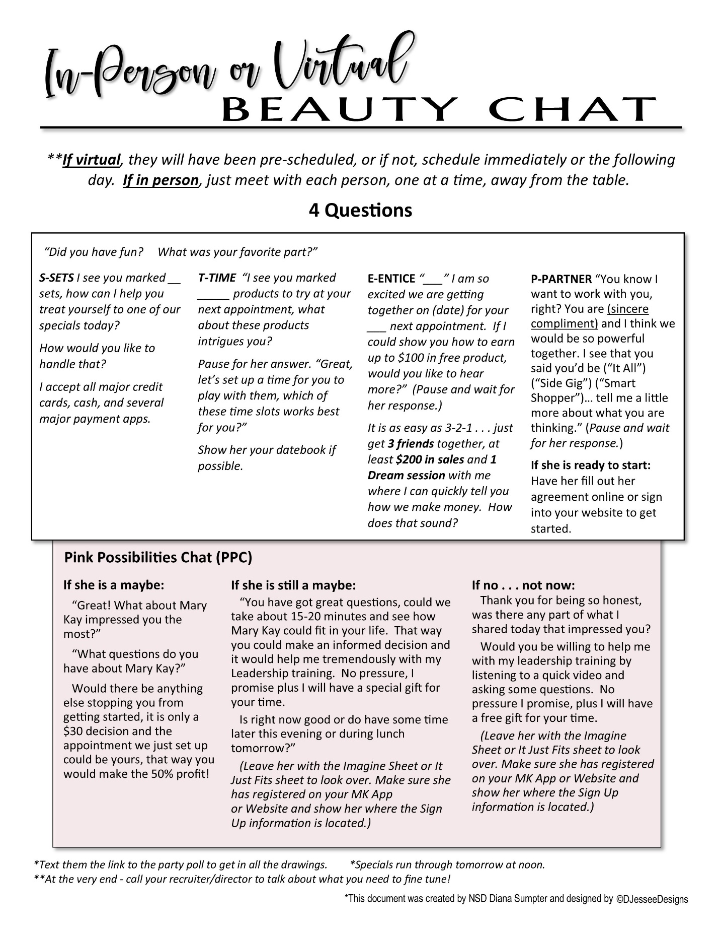

After the PJ Party follow up:

Those who were on live and commenting:
- Send Create a Roll up to each guest along with the Party Poll link: https://forms.gle/YqMU734rpeL78mRs7

- Leave a personalize audio message about how you appreciate their time and comments and ask them for about 5 minutes to do their beauty chat.

- The Specials run through noon the next day.

Then privately reach out to those who just viewed with no comments:
- Same as above

Those who were unable to attend:
- Tag them by typing their name in comments- clicking on box that comes up with their name.)

- Let them know this is the PJ party you were telling them about…would love to hear their feedback.

Your recruiter will pick out a couple of people to do the beauty chats together so you can hear how it should flow.

Send a quick message to your Recruiter/Director with the results of each Beauty Chat that way we can equip you to pivot if needed before you talk with everyone.

Remember the first 30 are practice, you WILL get stronger each time!! Soooo proud of you!

