THIS POST SHOULD BE UP BEFORE YOU INVITE ANYONE! ADD A PICTURE OF YOURSELF TO THIS POST. YOU CAN ADD PHOTOS OF YOUR FAMILY IF YOU FEEL COMFORTABLE AS WELL.
Welcome to <HOSTESS>'s Virtual Mary Kay Event! <HOSTESS>, I'd like to thank you for hosting your event with me!! I am so excited to meet some of your friends and family!!! Thank you for supporting my business In return I'll be spoiling you!
The event officially starts Monday <DATE> and goes through Friday <DATE>. This week I'll be teaching you all about skin care, a little bit of makeup, who and what Mary Kay is and I'll also be posting some live tutorials, games and PRIZES/GOODIE BAGS!
Please sit back, relax and enjoy! I'll be posting teasers leading up to Monday! All comments starting NOW count towards PRIZE entries!!
Please post below how you know <HOSTESS>, where you're from and what you're most excited to learn?

THURSDAY POST #1 BEFORE PARTY @ 10:00am
I want to send EACH of you a welcome goodie bag!
This is my way of saying THANK YOU for being apart of <HOSTESS>'s event! I have something special for each of you!!
Comment below if you would like me to mail you a goodie bag!
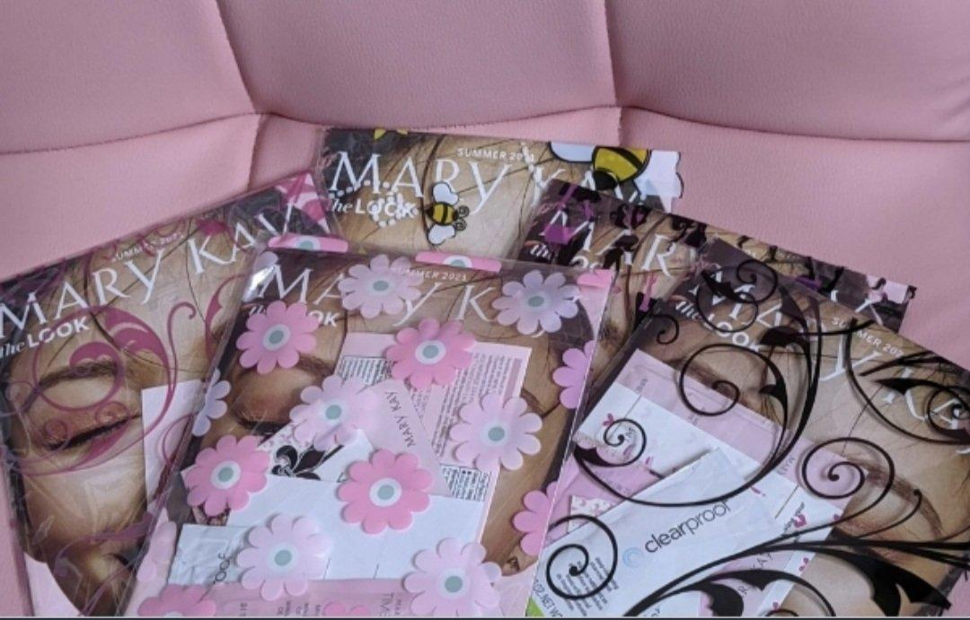

THURSDAY POST #2 BEFORE PARTY @ 6:00pm
Feel free to visit my Personal Mary Kay Website and start making your wishlist!!
Please be sure to register as a customer on my website for additional FREEBIES! Comment below if you are registered and get 2 PRIZE ENTRIES!!
<WEB ADDRESS TO YOUR MARY KAY WEBSITE>

FRIDAY POST #1 BEFORE PARTY @ 10:00am
Reminder for GOODIE BAGS!!
As a special THANK YOU, I want to send each of you a goodie bag!
I'd like to get these mailed out over the weekend so you have them during the event!!
Comment below and let me know if you'd like one!!
If you requested one in my last post, check your messages. I sent you a Private Message! Please respond and I'll get you your goodie bag!

FRIDAY POST#2 BEFORE PARTY @ 6:00pm
There is SO much to share!!
You won't want to miss it!! I'll be posting some teaser posts tomorrow and Sunday!!
What's your favorite??
Good cleanser
Moisturizer
Masking
Exfoliating
Comment below!
EVERY comment over the next few days is an entry for the prize drawings at the end of this event!
Don't forget to comment on ALL posts for MAX entries!!
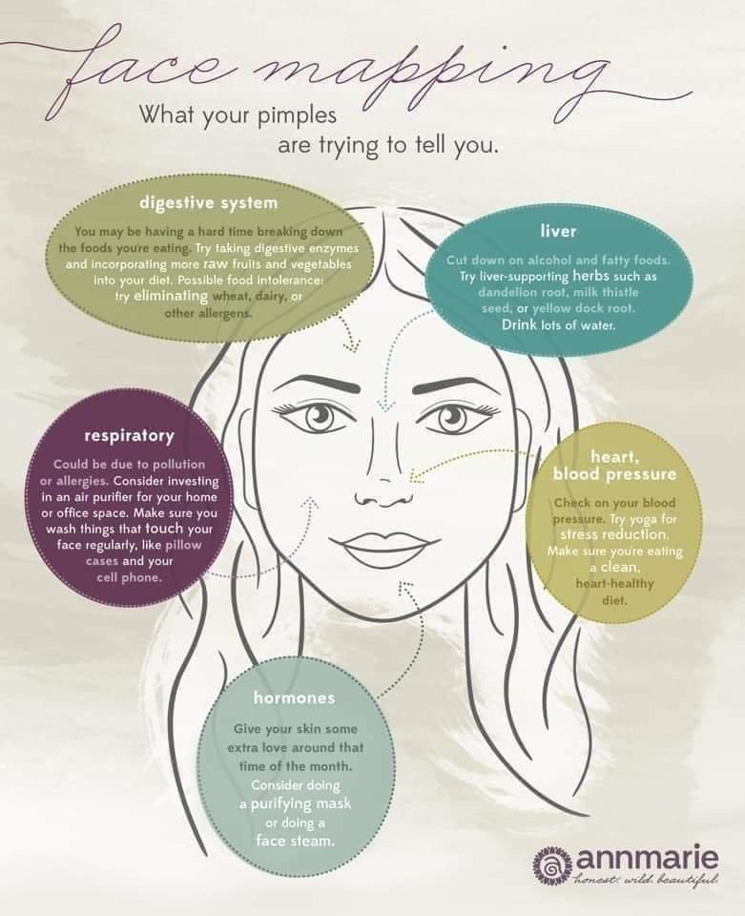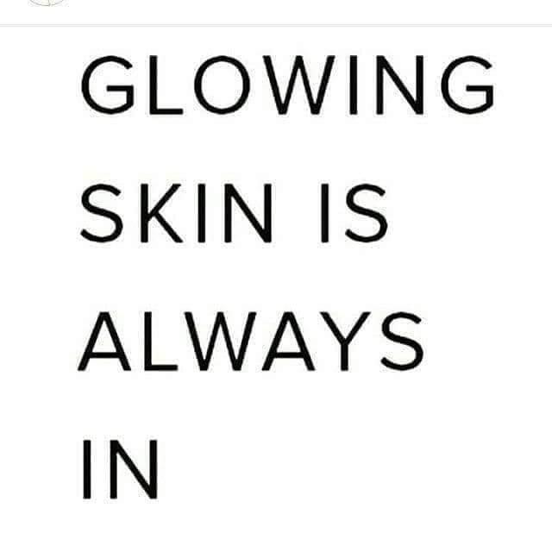

SATURDAY POST #1 BEFORE PARTY @ 9:00am
Over the next few days, you will learn who and what Mary Kay is and stands for (it's so much more than just a makeup and skincare company) you will learn about our amazing products; we will play some games and win some AWESOME prizes
Take a look at all of our amazing products that have received the Good Housekeeping Seal of approval.
The list includes:
-The full TimeWise Repair Set
-The full TimeWise Miracle Set 3D
- Hydrogel Eye Patches
-All of the TW 3D Foundations
-The Bio-Cellulose Mask
-The Clear Proof Charcoal Mask
-The Revealing Radiance Facial Peel
-The Deep Wrinkle Filler
-The Tone-Correcting Serum
-All of the Gel Semi-Matte Lipsticks
-The Lash Intensity® Mascara
-And The Oil-Free Eye Makeup Remover
This goes to show the quality of product that Mary Kay puts out to all of us! So amazing!
Did you know...Mary Kay is a TOP 5 brand GLOBALLY!! That's saying a lot for a product that's not sold in stores!
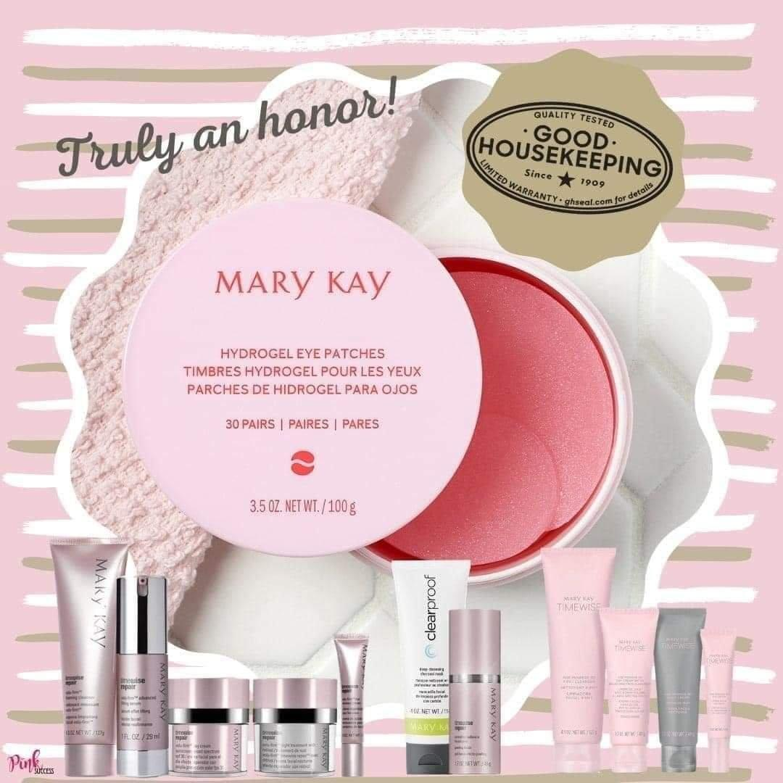
SATURDAY POST #2 BEFORE PARTY @ 12:00pm
Hey Ladies! Accept my friend request and get prize entries!!
When you accept my friend request, I'm able to notify you if you are a prize winner!!
Comment below with a GIF if we're friends!!
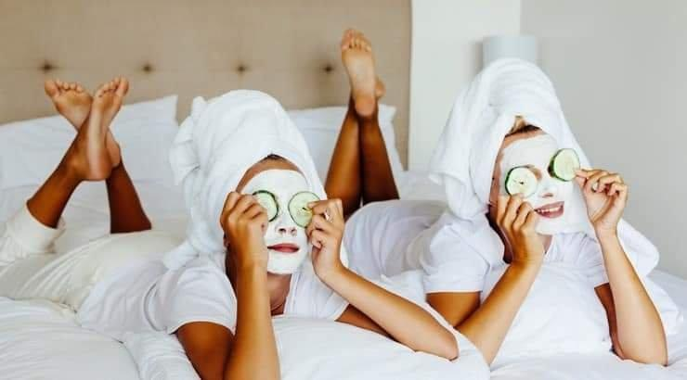
SATURDAY POST #3 BEFORE PARTY @ 2:00pm
Although I am fairly new to this business, I have listed a few reasons why I LOVE Mary Kay!
Over the next few days you will learn who and what Mary Kay is and what we stand for. This is SO much more than just a makeup and skincare company.
You will learn about some AMAZING products, we will play some super FUN games and win some AWESOME prizes!! Woohoo!!
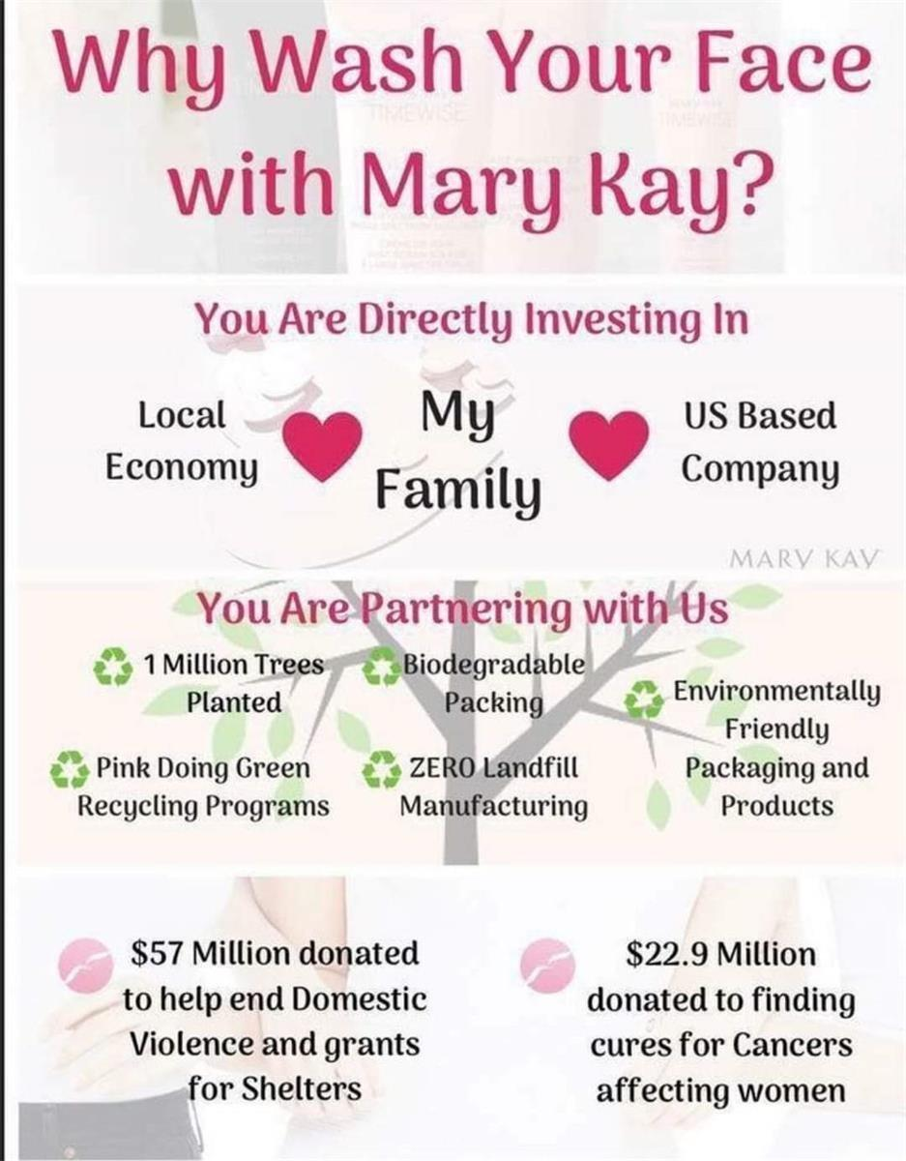

SATURDAY POST #4 BEFORE PARTY @ 3:30pm
Let's play a fun game while we wait! I'll be going LIVE Monday to kickoff the event Each comment/question = entry into the prize drawing! Let's get to know each other! I'm <INPUT YOUR COLOR INFO>!
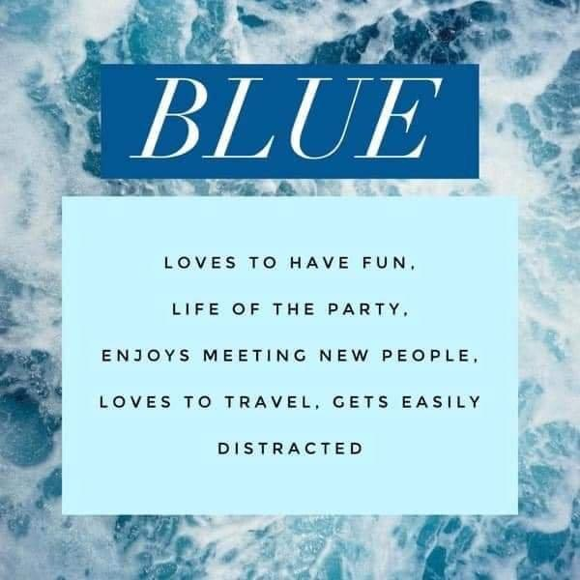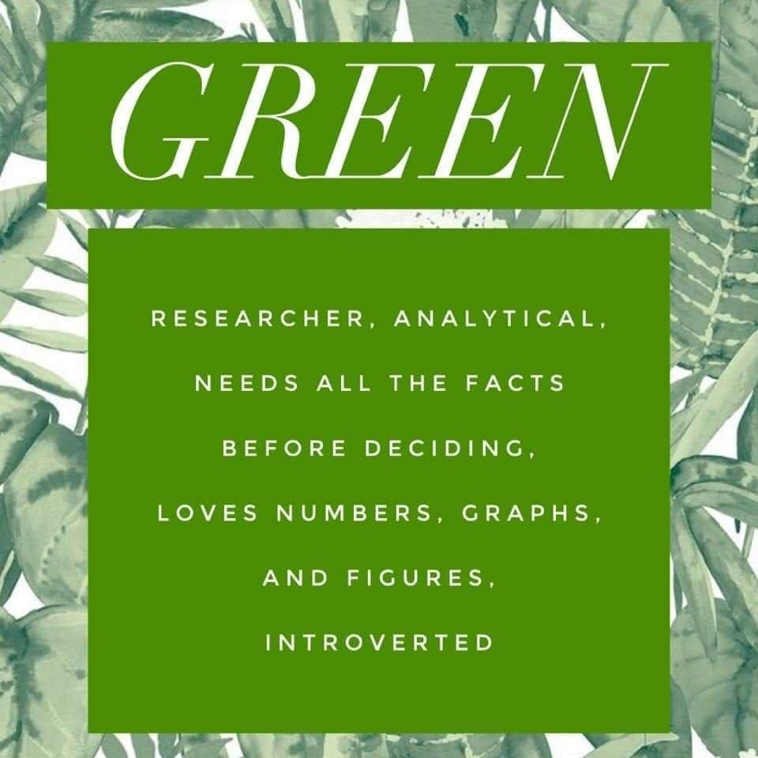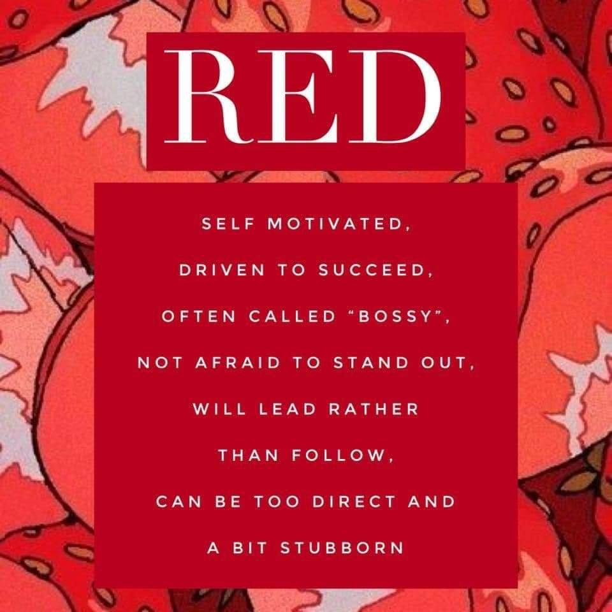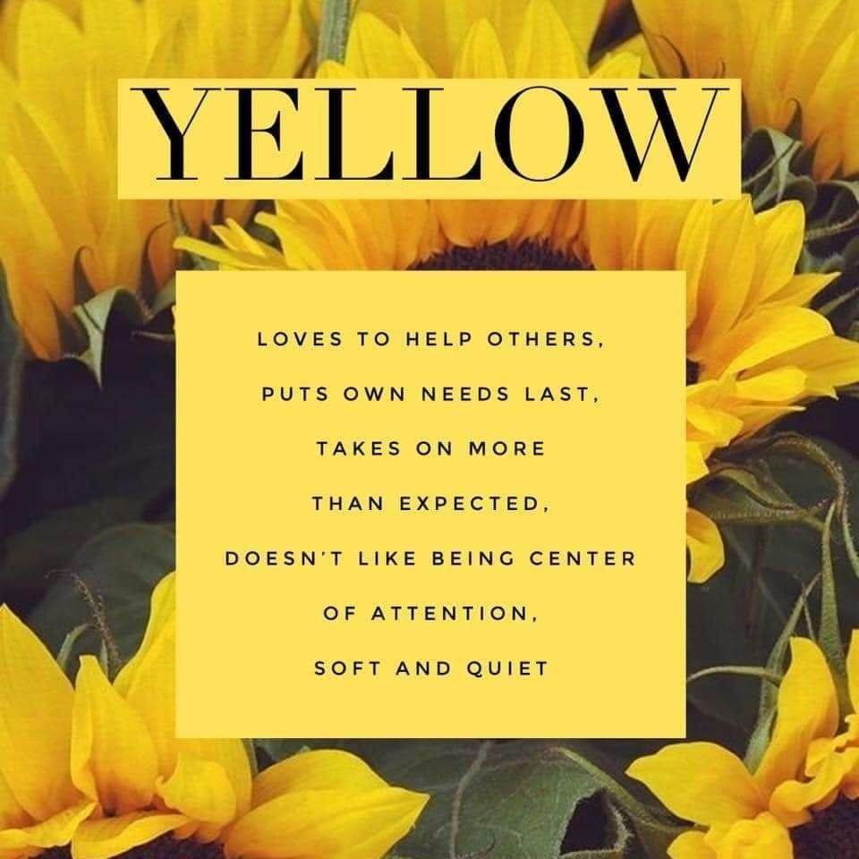

SATURDAY POST #5 BEFORE PARTY @ 8:00pm
Thank you for all your participation so far! You ladies are rock stars
If you haven't commented yet, you still have time to catch up! Each comment is an entry into the prize bag
The event officially starts Monday, but don't worry, I have some fun posts planned for tomorrow to get you all excited
This weekend is all about getting to know each other...so what's your coffee looking like Sunday Morning?
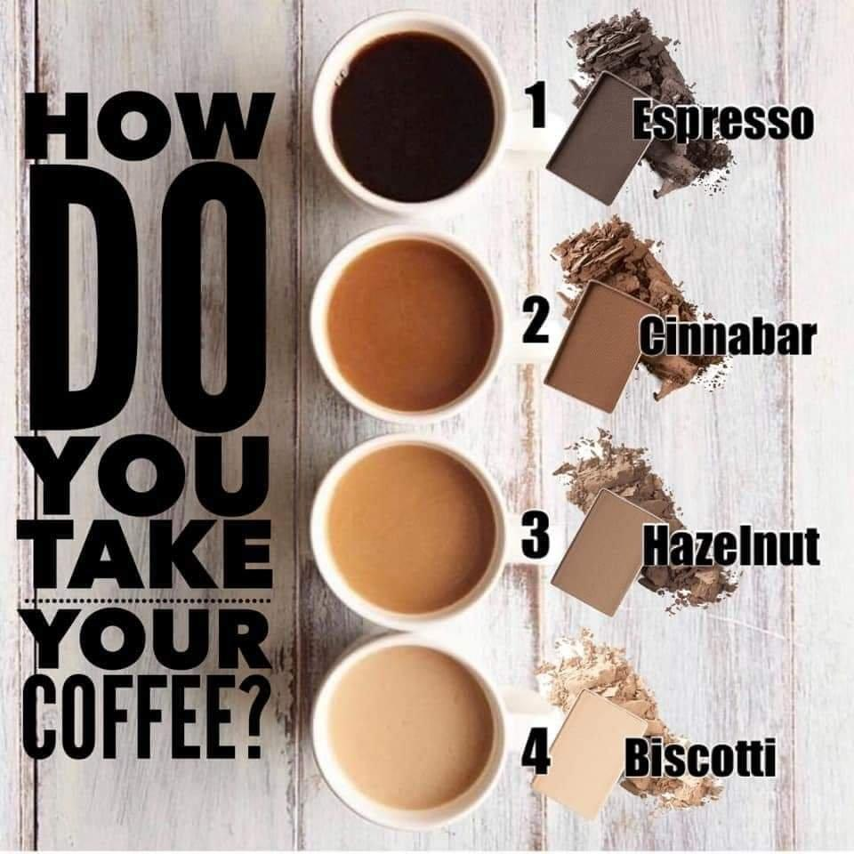

SUNDAY POST #1 BEFORE PARTY @ 9:00am
Good morning, Ladies! Only day away from fun, prizes and products!
If you haven't commented, there's still time to go back and start getting your prize entries!
Each comment = prize entry
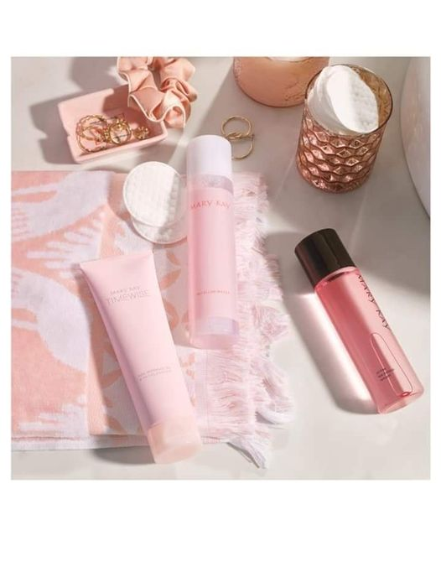
SUNDAY POST #2 BEFORE PARTY @ 12:00pm
GIVEAWAY GUIDELINES
I will be doing prize drawings on Wednesday!!
entry for joining the group AND accepting my friend request/commenting on posts!
entry for every comment/question.
entries when you comment on my live videos about what you learned/loved!
entries when you watch me Live
Watch me LIVE Tomorrow <TIME> to see what the prizes will be

SUNDAY POST #3 BEFORE PARTY @ 3:00pm

The NEW Mary Kay® App is sure to be your new beauty BFF!

With it, you can uncover your own customized skin care routine and receive the perfect product recommendations. Shop, create a wishlist, place product reorders and discover new products!
Please be sure to also list me as your Beauty Consultant
Ready to get started on your Beauty Profile? Download the free Mary Kay App from your app store!!
Post a screenshot of the app showing you've listed me as your Beauty Consultant and earn prize entries!
Android: https://play.google.com/store/apps/details...
IPhone:
https://apps.apple.com/us/app/mary-kay-app/id1585001346
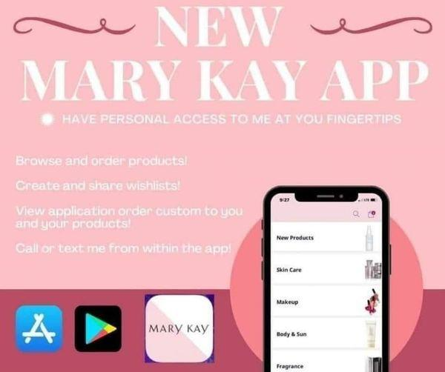
SUNDAY POST #4 BEFORE PARTY @ 5:00pm
This feature is SUPER important and will help make sure you don't miss anything during the event!
Post a screenshot in the comments showing you turned your notifications to "ALL" for the group and you will get additional entries into the prize bag!!!
The party OFFICIALLY starts tomorrow, and I will be going LIVE at <TIME> tomorrow... You won't want to miss this!!
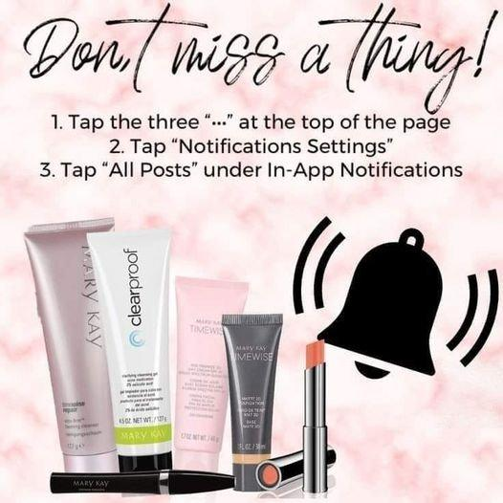

SUNDAY POST #5 BEFORE PARTY @ 7:30pm
Party starts tomorrow!!! While we wait, let's share below!!
I am definitely the “Graceful-ager”!
Remember!
Comments = Entries into the prize bag!!!!!
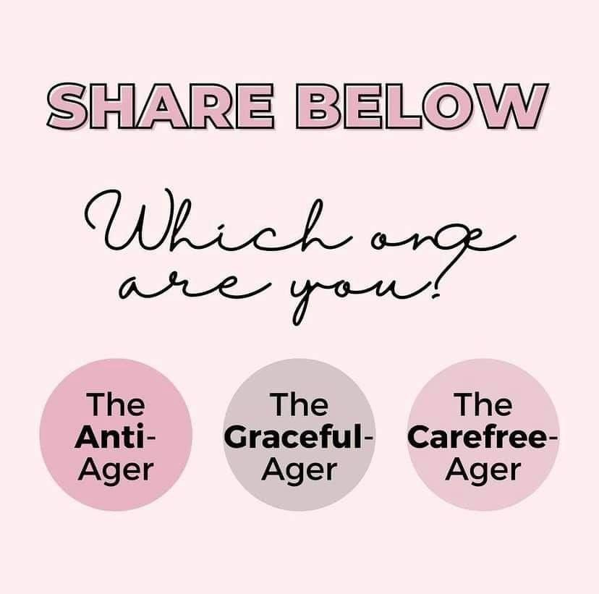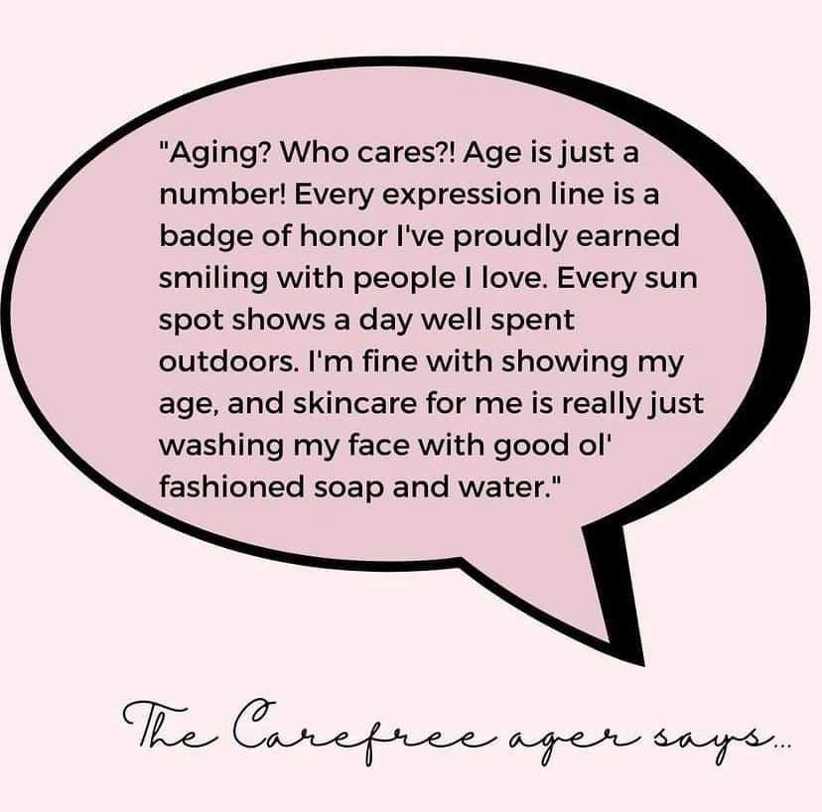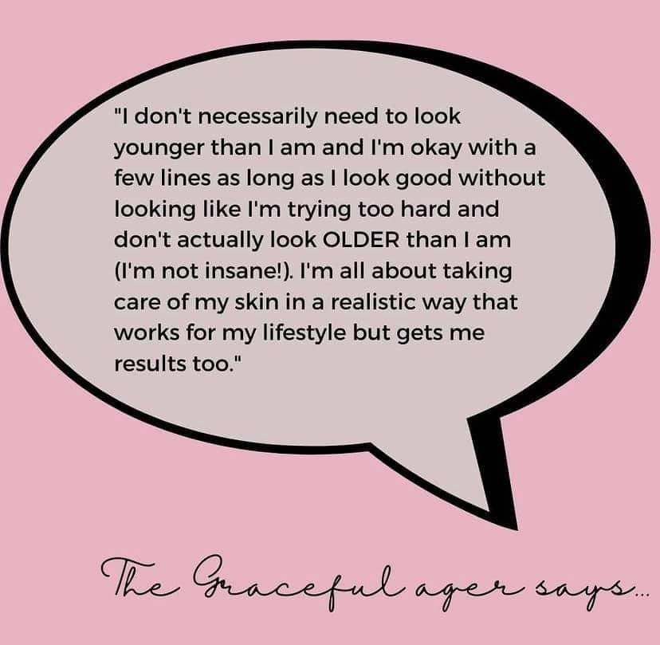

MONDAY POST #1 @ 9:00am
Here's a little Monday Fun Fact!
Is product safety important to you?
Mary Kay is EU compliant. Which means we follow the European guidelines and not the United States. Did you know, the United States only bans about 30 ingredients when it comes to skin care and cosmetic products...Europe bans over 1300! This is why we choose to follow European guidelines!
On that note......
You ladies ready!!
Event officially starts today!!
I'll be going LIVE at <TIME>! Watch me LIVE for Prize entries!!
If your excited, leave a in the comments!
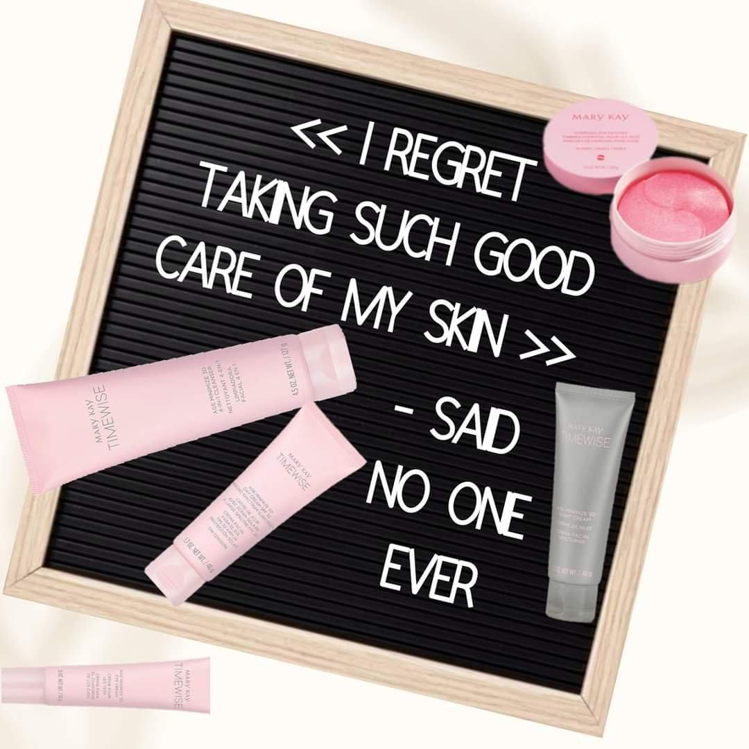

MONDAY POST #2 @ 11:00am
Catch me LIVE at <TIME>!!
Here we go ladies!!! Let's get the party started with our #1 skin care line!!!
Timewise 3D.
It’s where the magic begins! In formulation for 6 years before being launched, this quick and easy patented 3-step system will turn back the hands of time on your skin. A breakthrough 3-dimensional approach to skin care, Timewise 3D will defend, delay and deliver incredible results for all skin types. Resveratrol, age-defying peptides and Vitamin B3 are present in all 3 steps—ensuring smoother, brighter, and much younger skin in just 4 weeks!
~DEFENDS against age-accelerating free radicals on skin with multiple antioxidant benefits.
~ DELAYS the look of premature skin aging with broad-spectrum UVA/UVB protection.
~DELIVERS visible improvement of fine lines and wrinkles in as little as 4 weeks!
I can personalize this skin care routine for your specific type of skin!
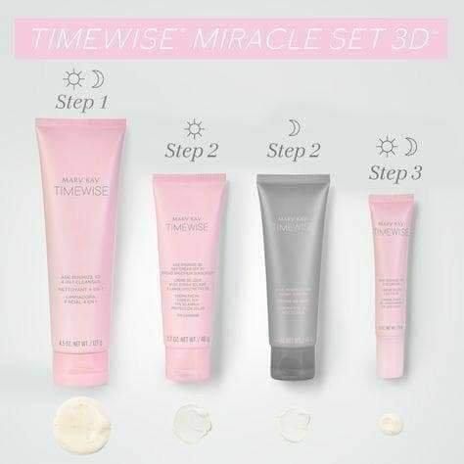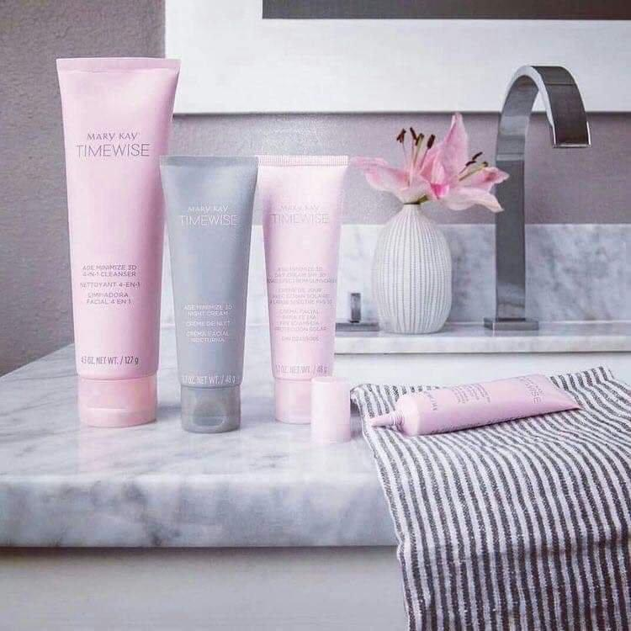

MONDAY POST #3 @ 1:00pm
Let’s talk MULTIMASKING!
Escape the stress of daily life with some much-needed R&R!
We’ve got the targeted solution to balancing unpredictable weather and a clear, hydrated complexion!
Get excited about multi-masking!
Check out this powerful duo that will renew stressed/dull/dry skin, as well as unclog pores and instantly refresh and brighten the face!
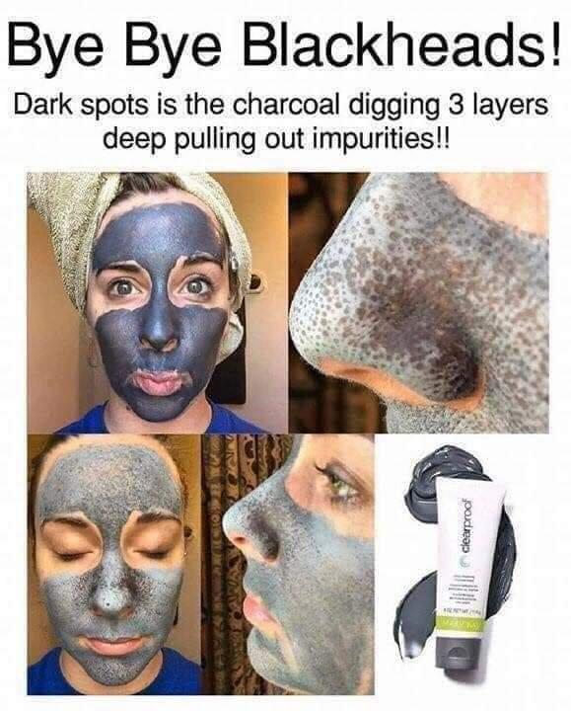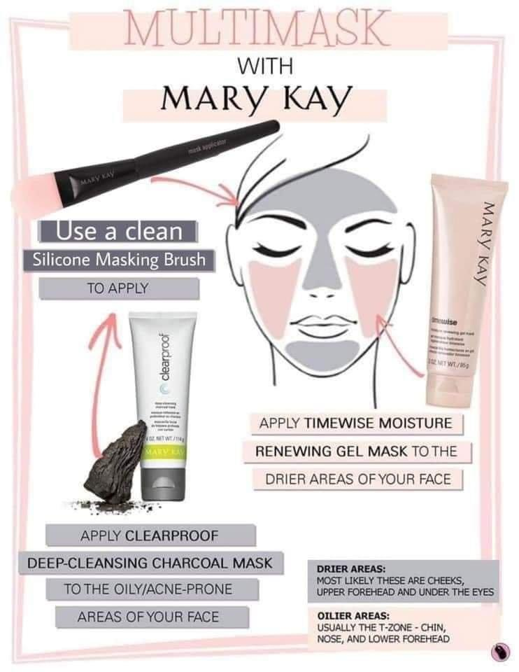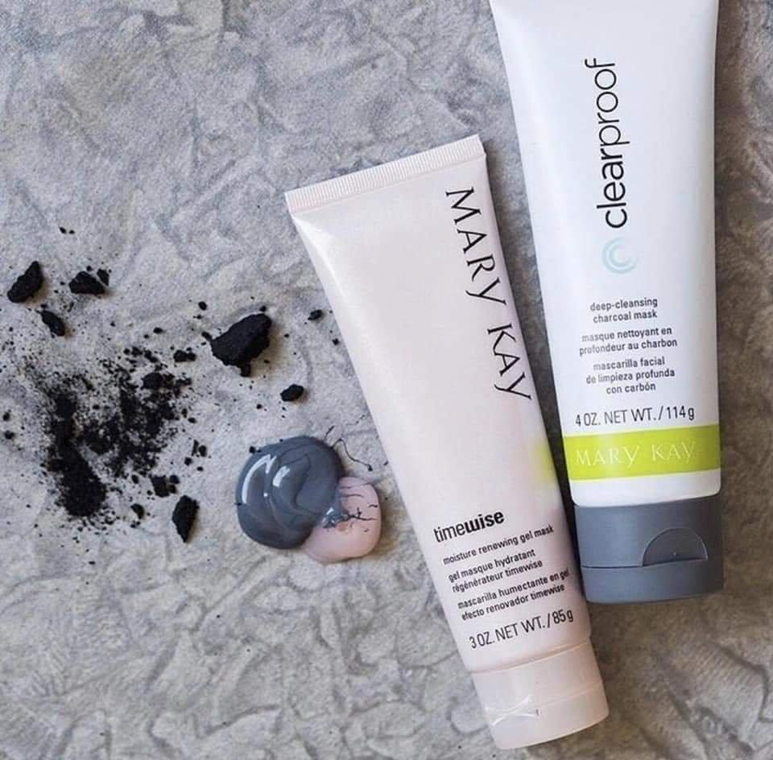
MONDAY POST #4 @ 3:00pm
Continue to take care of your eye areas with our Hydrogel eye patches and Soothing eye gel!!
Hydrogel eye patches:
These patches deliver a refreshing burst of hydration to your eyes!
Instantly cool and soothe
Immediately boost skin hydration
Diminish look if puffiness and dullness
For extra cooling and calming, pair with our Soothing Eye Gel!!
Soothing Eye Gel:
Contains green tea extract which is known for its free radical scavenging and skin calming properties!
Reduces the look of puffiness while also toning and firming
You can also pop these in the refrigerator to give that additional cooling and soothing effect!
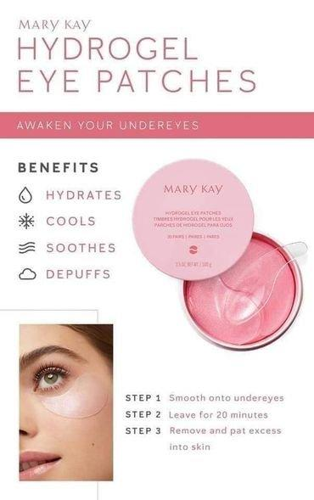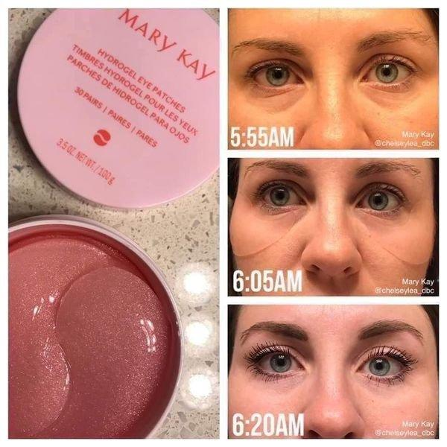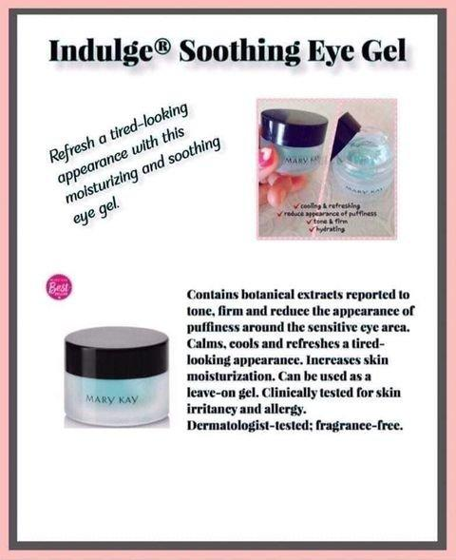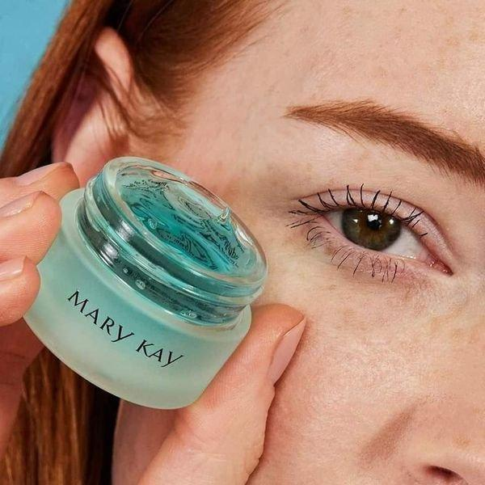

MONDAY POST #5 @ 5:00pm
Make sure to check back at <TIME> for a fun game and a chance to win a prize!!
It's time to talk about EXFOLIATING & MINIMIZING PORES!!
Timewise Microdermabrasion and Pore Minimizer
Using this product once a month to exfoliate away dead skin cells is so important!!!
Dramatically improves your skin's texture
Visibly improves the look of fine lines and immediately pores look smaller
Timewise Repair Facial Peel
This is a great non-abrasive way to exfoliate! Perfect for sensitive skin!!
Lightweight serum gently exfoliates several skin layers deep and breaks down dead skin cells!! Leaving skin refreshed and revived
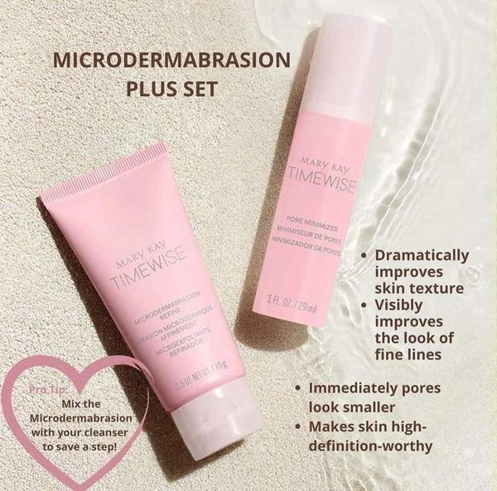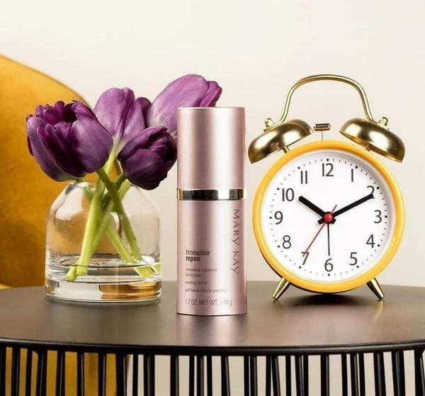

MONDAY POST #6 @ 6:00pm
HERE ONE OF OUR MOST POPULAR LINES!!
SATIN HANDS
Instantly hands feel moisturized, soft and smooth! With constant hand washing, my hands get very dry and cracked!! Satin Hands has been a lifesaver! Comes with a hand softener, exfoliator and lotion!
SATIN LIPS
I am ALWAYS putting in chapstick or lip balm. Satin Lips has been a game changer for me! You exfoliate with a Shea Sugar Scrub to remove dry skin and then lock in moisture with the Shea Lip Balm! I literally carry this everywhere I go!!
Satin Hands Shea Hand Soap Blended with moisturizing, nourishing shea butter.
Hands are thoroughly cleansed and purified
Does not leave hands overly dry
Blended with nourishing shea butter
Soft, comforting lather
Fragrance-free
Satin Hands Shea Hand Sanitizer
Takes hand care to the next level, featuring a quadruple blend of moisturizing ingredients so you can clean and sanitize your hands while soothing skin.
Kills 99.9% of common harmful bacteria
Helps soothe skin
Shea butter, aloe vera, glycerin and betaine
Dries quickly and is not sticky
Portable, travel-friendly spray
Fragrance-free
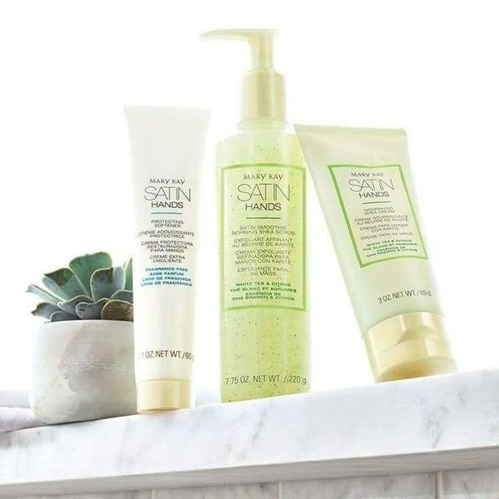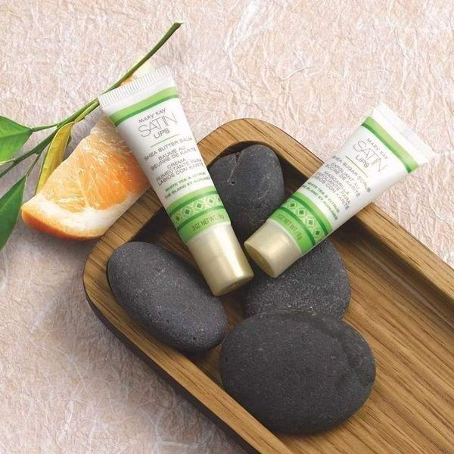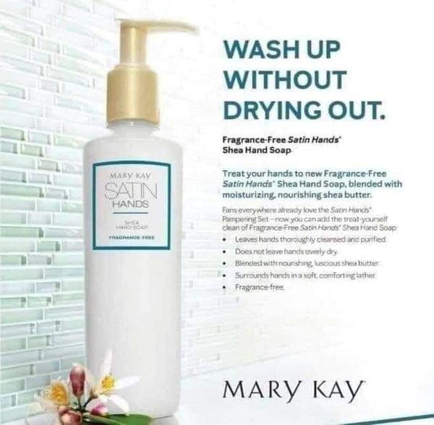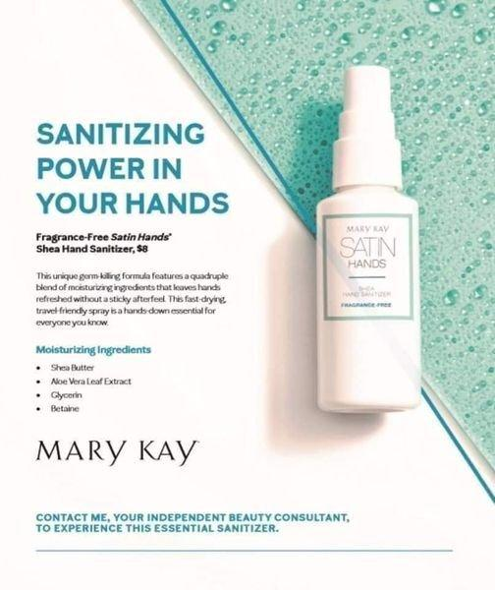
MONDAY NIGHT GAME POST @ 8:30PM -
YOU CAN CHANGE UP THE TYPE OF GUESSING GAME IF YOU FIND OTHERS YOU LIKE. AS GUESTS COMMENT THEIR GUESSES, MAKE SURE TO RESPOND BACK SAYING IF THEY NEED TO GUESS HIGHER OR LOWER. YOU CAN DECIDE ON A PRIZE THAT YOU WISH (IDEAS: 10% OFF THEIR ORDER AND IF THEY HOLD A DREAM SESSION APPOINTMENT WITH YOU, MAYBE BUMP THE DISCOUNT TO 20%)
GAME TIME
Who can guess how many Mary Kay brushes are pictured below??
You can guess more than once! Here are the rules:
You must wait until I respond to your guess before you guess again
OR
Wait until another person guesses, then you can guess again!! So keep trying until someone wins!!
Game goes until Wednesday at NOON! Closest guess without going over wins a special prize!!
Going LIVE at <TIME> tomorrow night and sampling some AMAZING products for you all to see!!

TUESDAY POST #1 @ 9:00am
Happy Tuesday ladies! Let's talk about makeup!
I want to start with primers. To have the best makeup look, you need to create the best base (starting with a great skincare routine of course )!
Once you've cleansed and moisturized, a primer is key to creating an amazing makeup look.
Whether you are doing a dash out the door look or you are getting ready for a night out on the town, adding primer to your routine will have your makeup looking on point all day (or night )!!

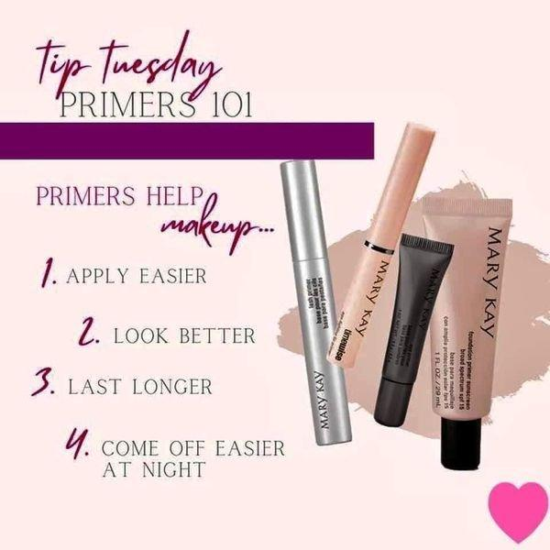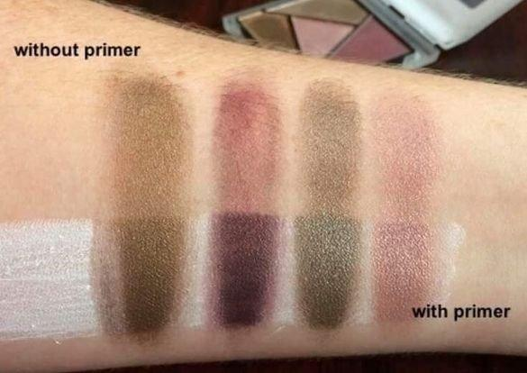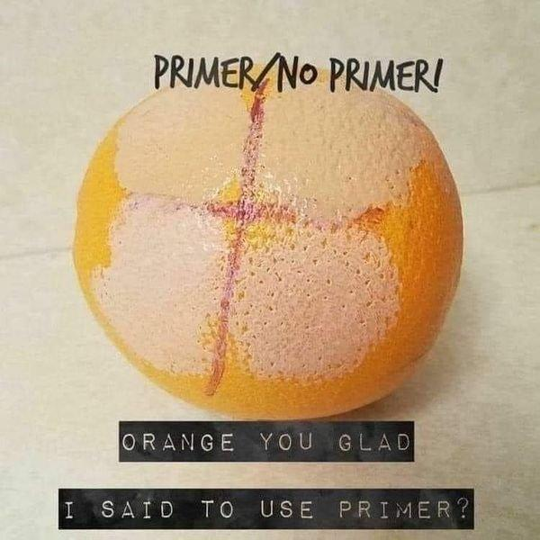
TUESDAY POST #2 @ 11:00am
This Oil Free Eye Makeup Remover is a MUST!!
Gently removes all types of eye makeup, without leaving skin feeling greasy!
VOTED #1 IN THE COUNTRY!!!
The skin around your eyes has less collagen and elastin than skin elsewhere on the face. Protect it by cleaning your makeup off gently every night and also enjoy the conditioning it does to your lashes
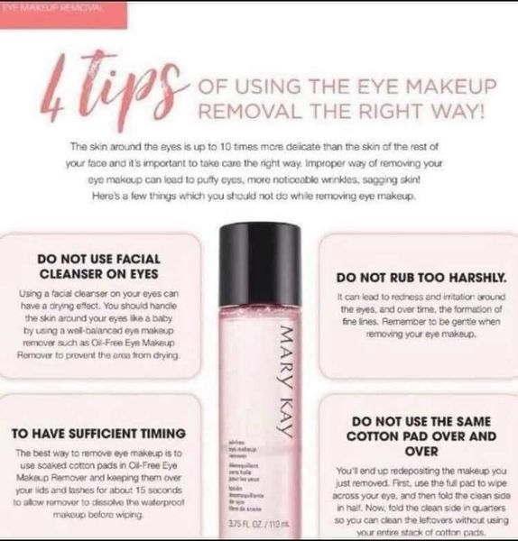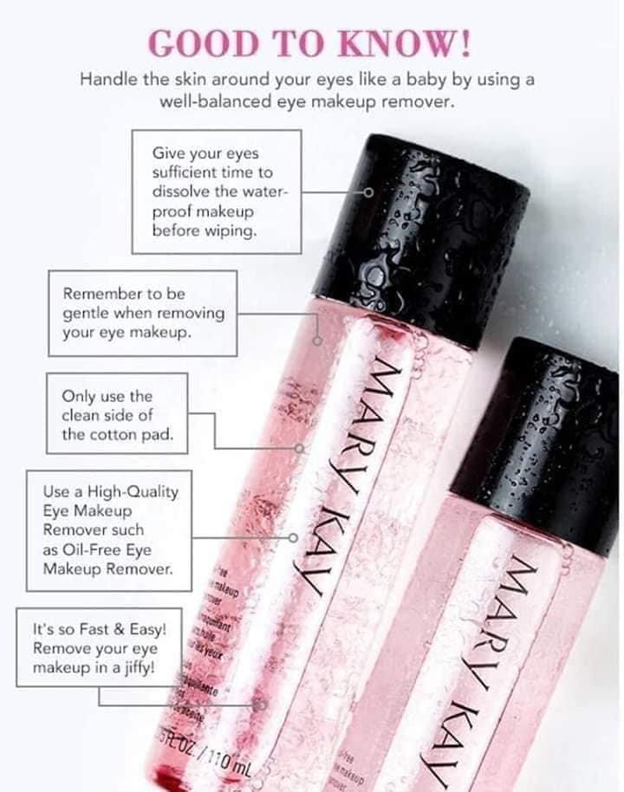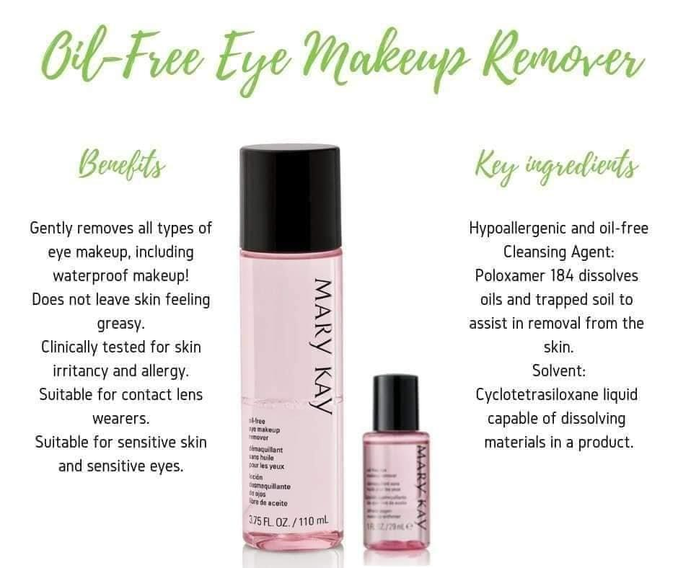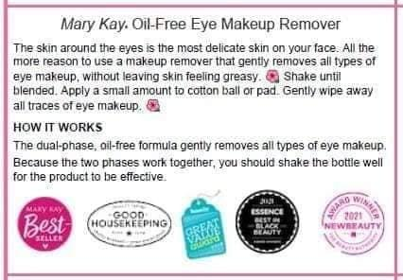

TUESDAY POST #3 @ 12:30pm
I know choosing a shade can be tough. I'm here to help with that! We have some wonderful foundation options that give you a fabulous look that's great for your skin as well! Timewise 3D Foundations are AMAZING! (Trust me...I have tried A LOT of foundations!) Seamless coverage with intelli-match technology, skin-brightening ingredients, anti-aging benefits, and long-wearing and transfer-resistant! What more could you ask for?? We also have the CC Cream which is great for a quick casual look as well as our NEW Silky Setting powders to help even skin tone and blur minor imperfections. Take this quiz to find your most likely shade! Post your shade below for entries into the drawing!!
Quiz link: survey.alchemer.com/s3/5067977/Foundations-Quiz-2019-06-14-US?fbclid=IwAR1d_VUv1u7-JEumO-B0rabjOhb8NQ_1TF04t3qOQd984XtG8tq3eJAOK5k
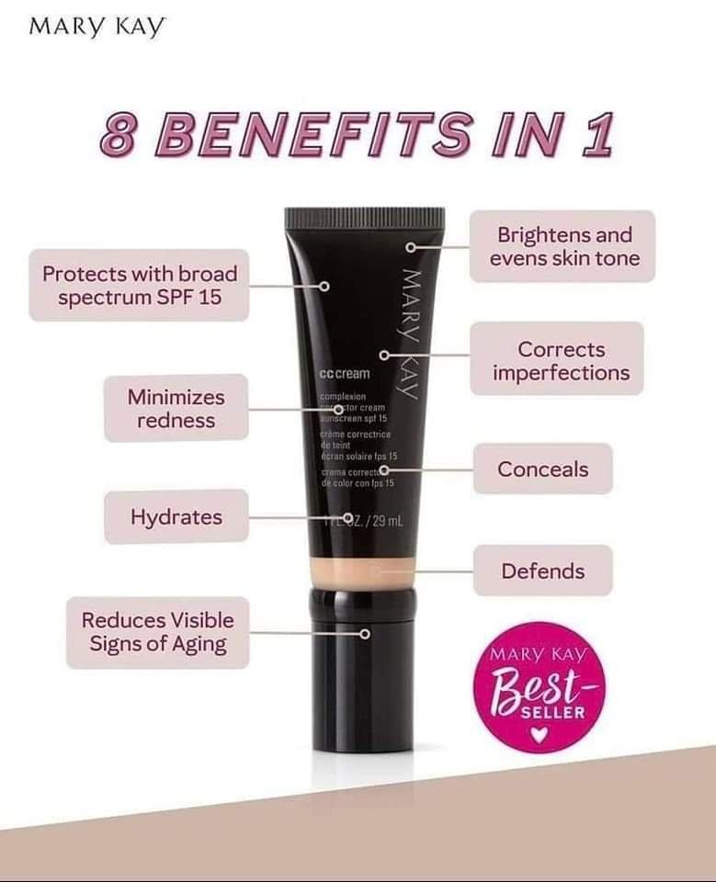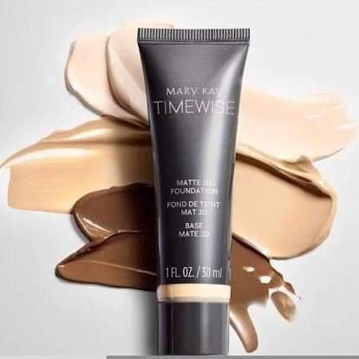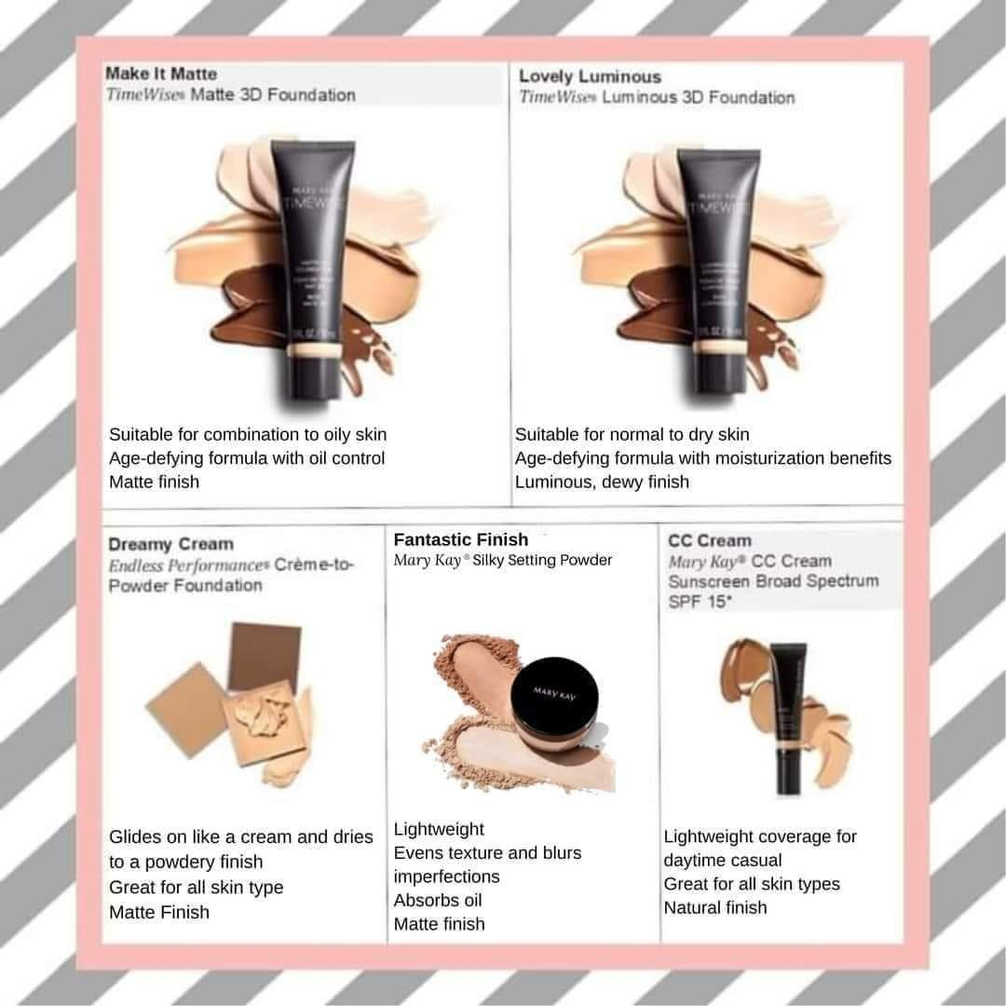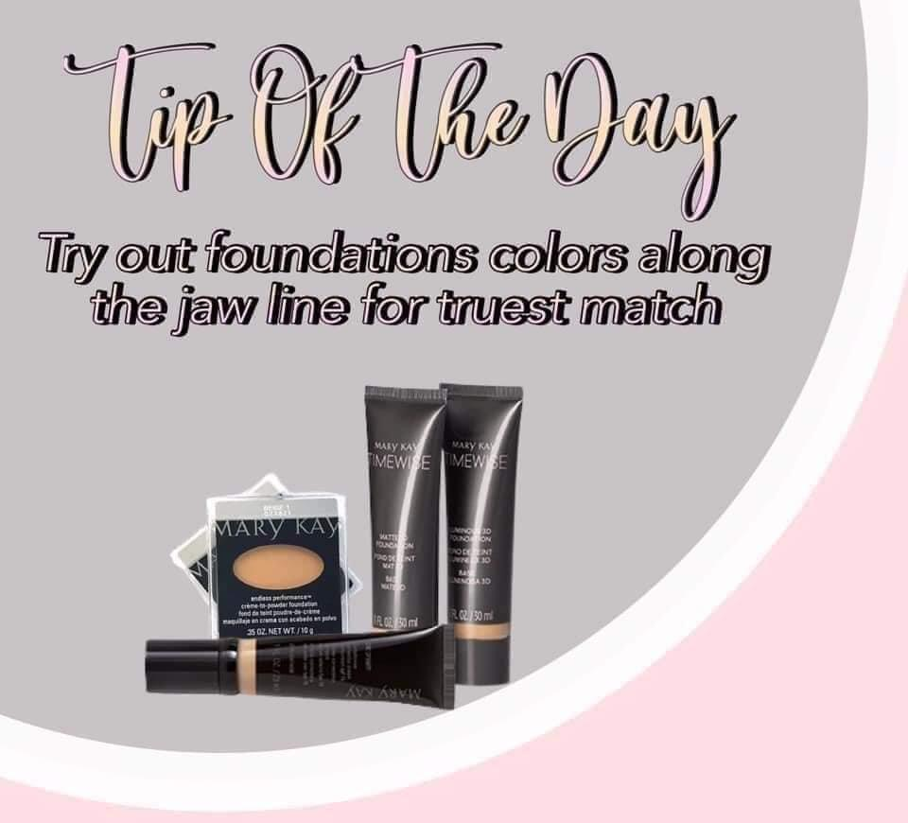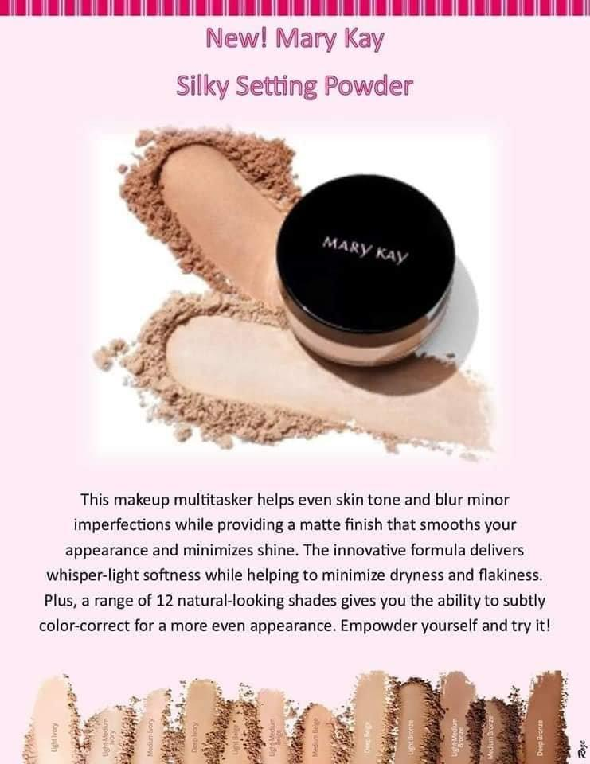
TUESDAY POST #4 @ 2:00pm
Up Next.....Mascara galore!!
I LOVE mascara!! If I'm looking for a quick "out the door" no fuss look, I always put mascara on! It makes my eyes pop and I love that!!
Love YOUR Lashes!
Comment below and let me know what you look for when picking a mascara?
volume
lengthening
defining
waterproof

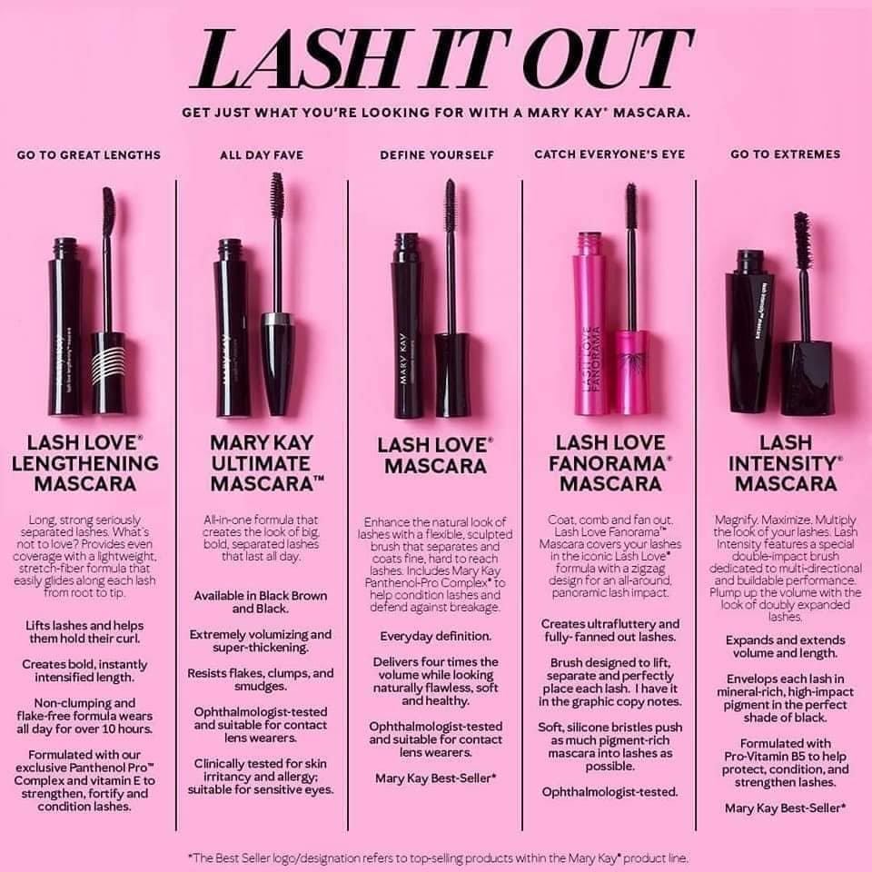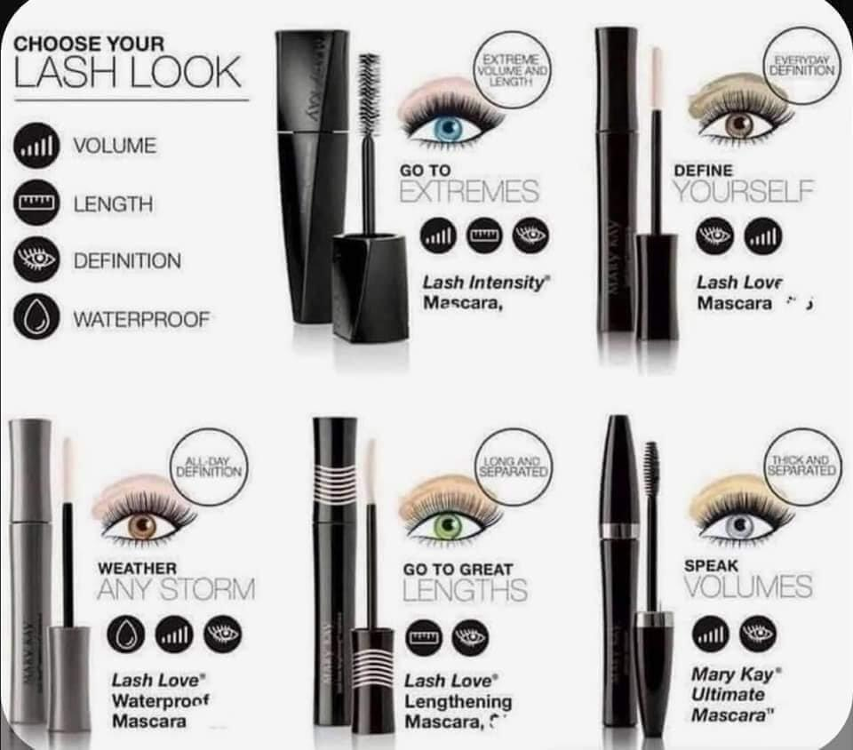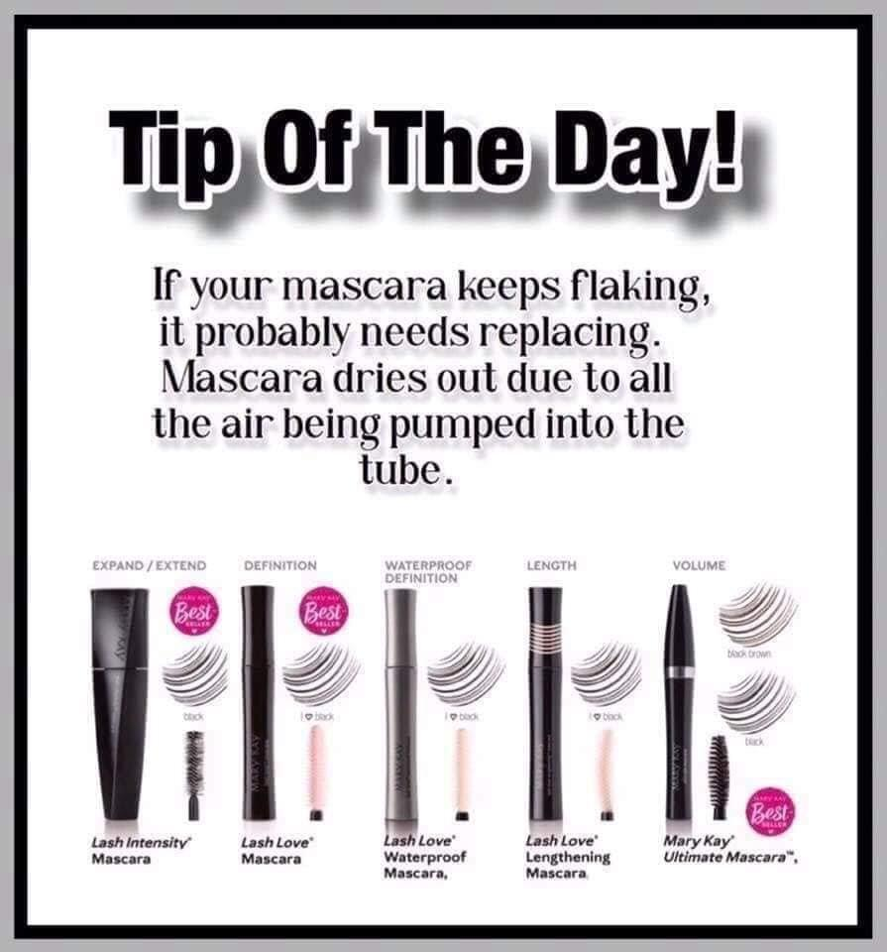

TUESDAY POST #5 @ 3:30pm
Aren't these eyeshadows just perfect!!
Mary Kay Liquid Eye shadows!
LIQUID EYESHADOWS
These are my go-to eyeshadows for a quick dash out the door eye look!!
Light up your lids with pigment-packed shades that add instant intensity! The creamy formula feels delightfully decadent. A doe-foot applicator creates effortless eye looks. Available in awesome shades!! It was also featured in O(Oprah)Magazine!!!
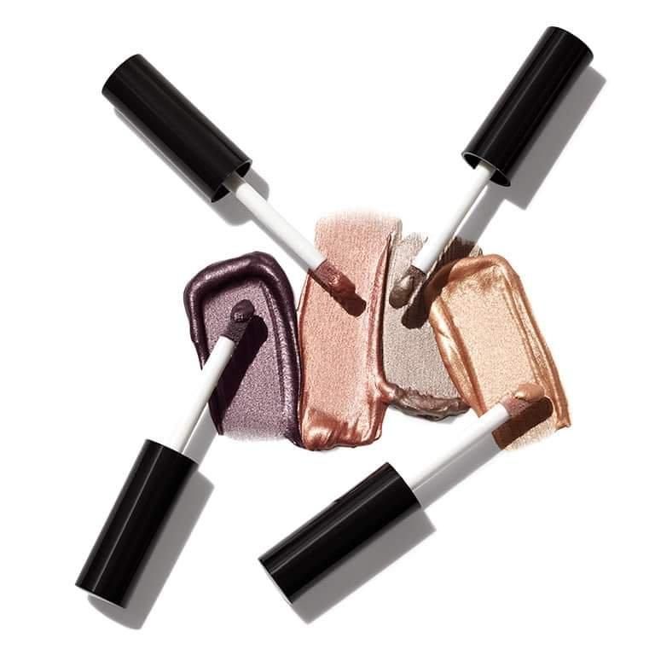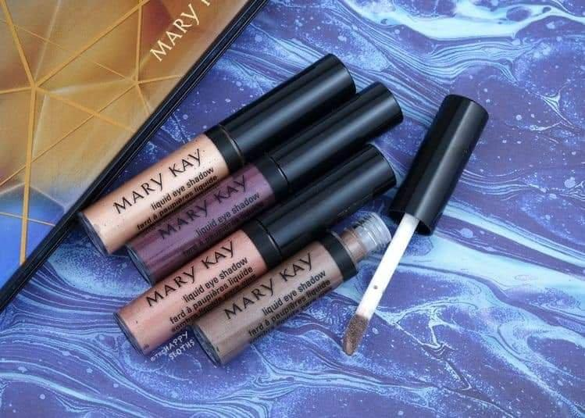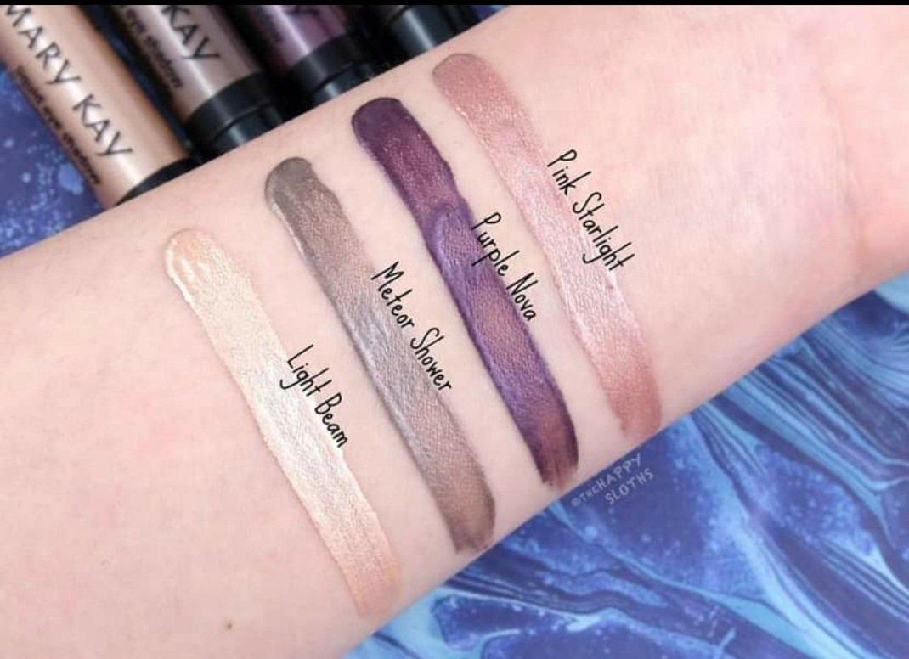

TUESDAY POST #6 @ 5:30pm
These NEW Supreme Hydrating Lipsticks nourish lips with sunflower oil and vitamin E!
Rich color and Brilliant shine available in gorgeous shades.
Which color are you grabbing first?
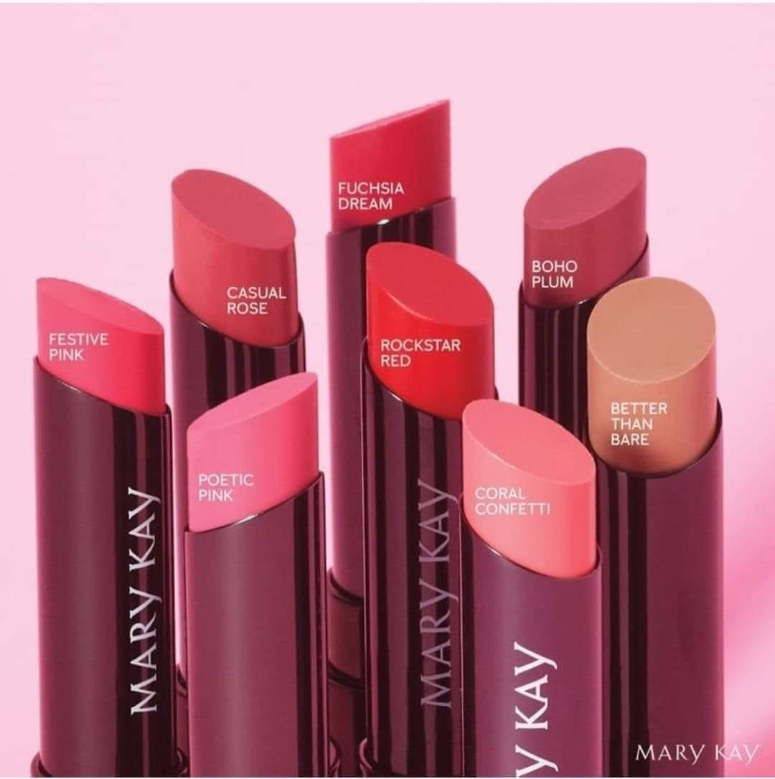

TUESDAY POST #7 @ 6:30pm
LIPS GALORE
What's your style?
*Comment under each picture your favorite color**
Check out all our new Lip glosses below! Such fun colors and shades!! Which colors are your faves??
These new lip glosses apply smoothly with a contoured lip applicator, making you need only a little bit and achieving long lasting wear! They come in finishes
Cream
Shimmer
Pearl
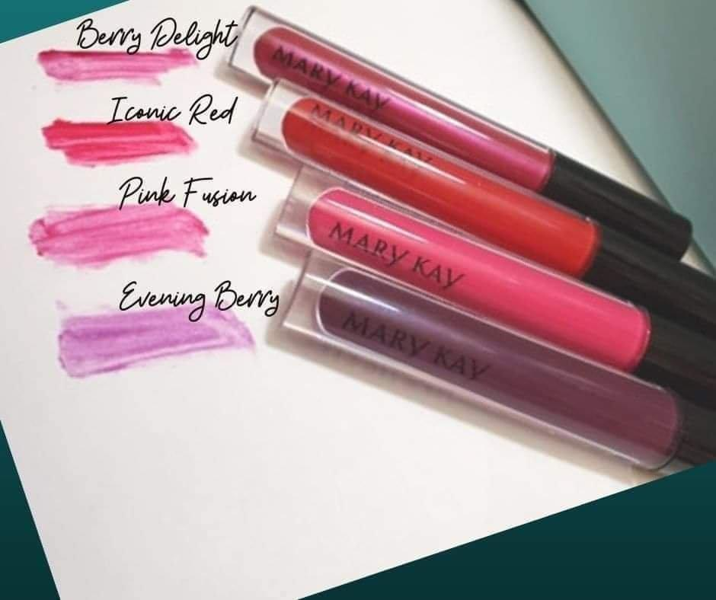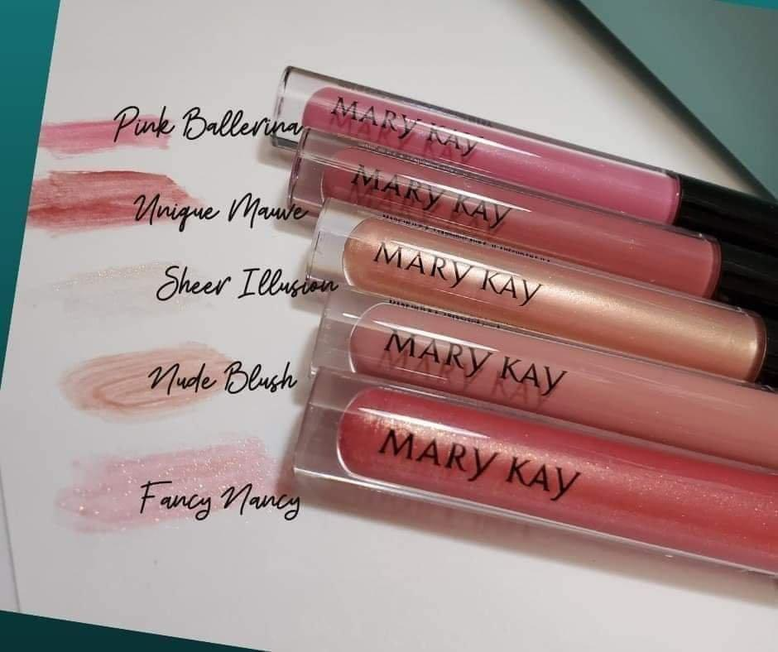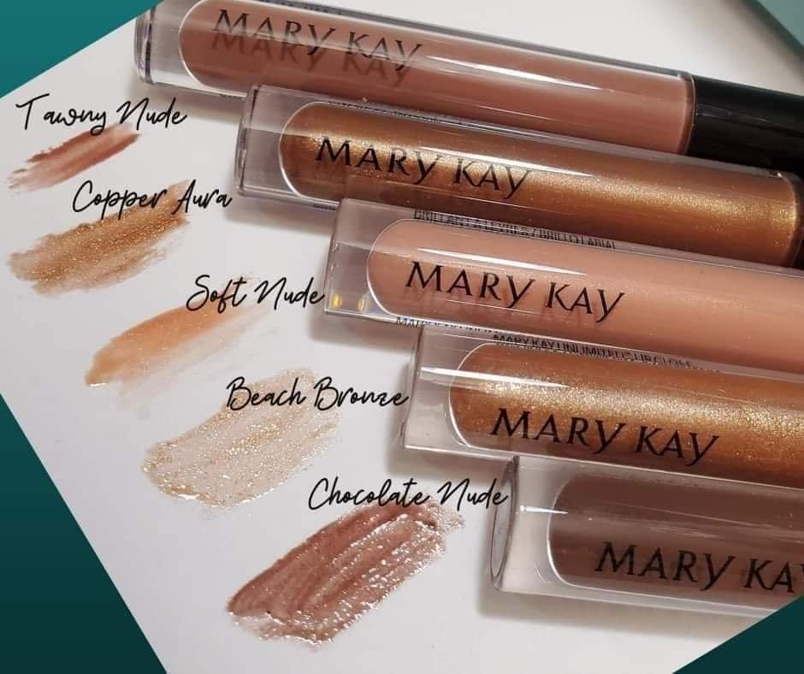

TUESDAY POST #8 @ 8:00pm
WOW! How much fun is this event!!! Did you know...you all can make an extra income by doing parties like this, right on your phone/computer!!
Have you ever wanted your own small business?
A little side gig for some extra money?
Do you have a Plan B in place for when life throws you a curve ball?
Comment below with a question you have about what I do! No obligations, but it helps YOU earn extra PRIZE ENTRIES !
EACH question you ask will get you prize entries for the drawing tomorrow at <TIME>
SO ASK AWAY!!
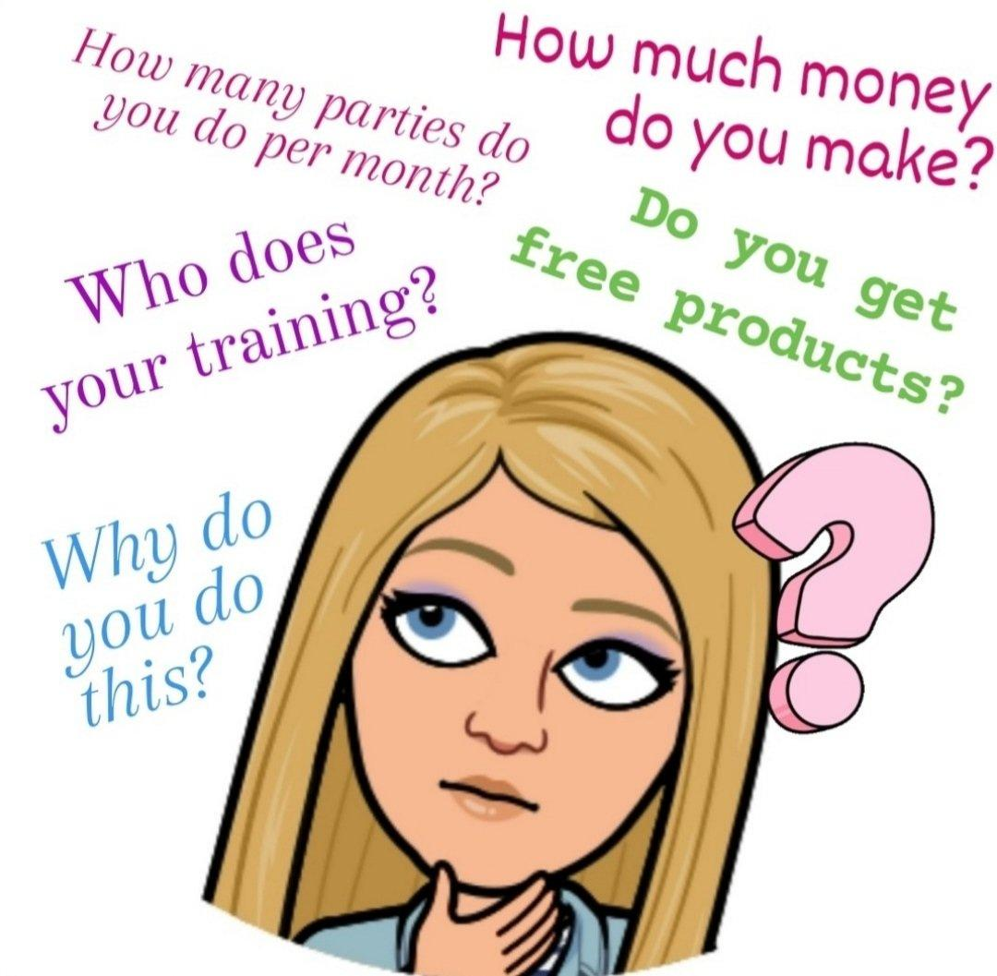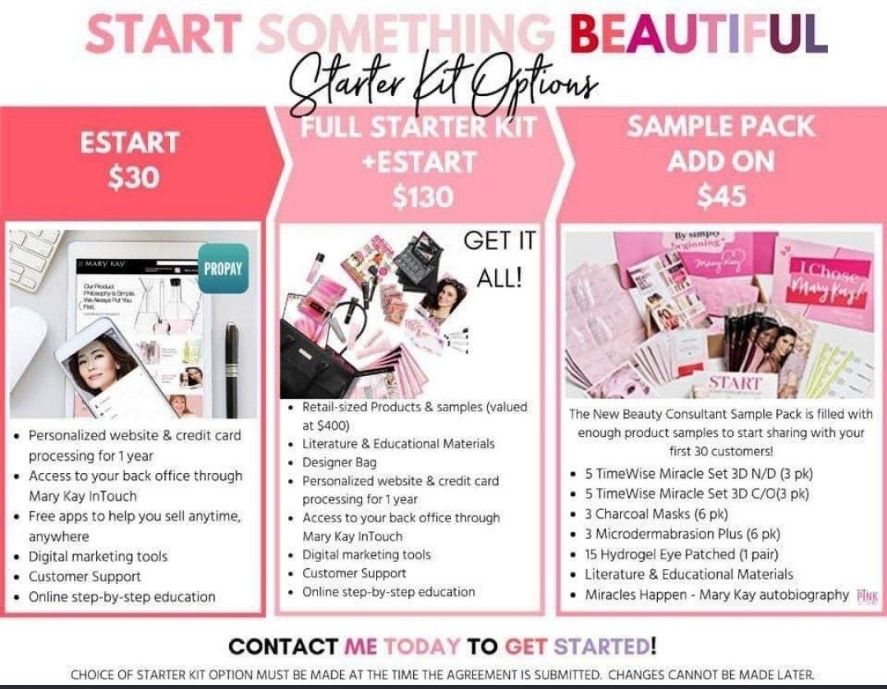

WEDNESDAY POST #1 @ 9:00am
I'll be going LIVE at <TIME> to announce some sales and the winners of the prizes!
Three ways to order
1. Via my website below. Be sure to check out as a registered customer (so important)!! I'll be able to throw in freebies and apply your discounts!! This is the best option if you want to pay with a credit/debit card.
2. Mary Kay app (also please choose me as your MK consultant )
3. Via messenger. We can chat about your order, and I can help make suggestions! This is the best option if you want to pay via Venmo.
Website link:
<YOUR WEBSITE LINK>

WEDNESDAY POST #2 @ 11:00am
Do you need help trying to decide on products?
Do you have oily skin?
Dry skin?
Dark Circles?
Large Pores?
Find the picture below that best describes your skin issue and see which products are the best for that!!
Have questions? Please don't hesitate to ask!
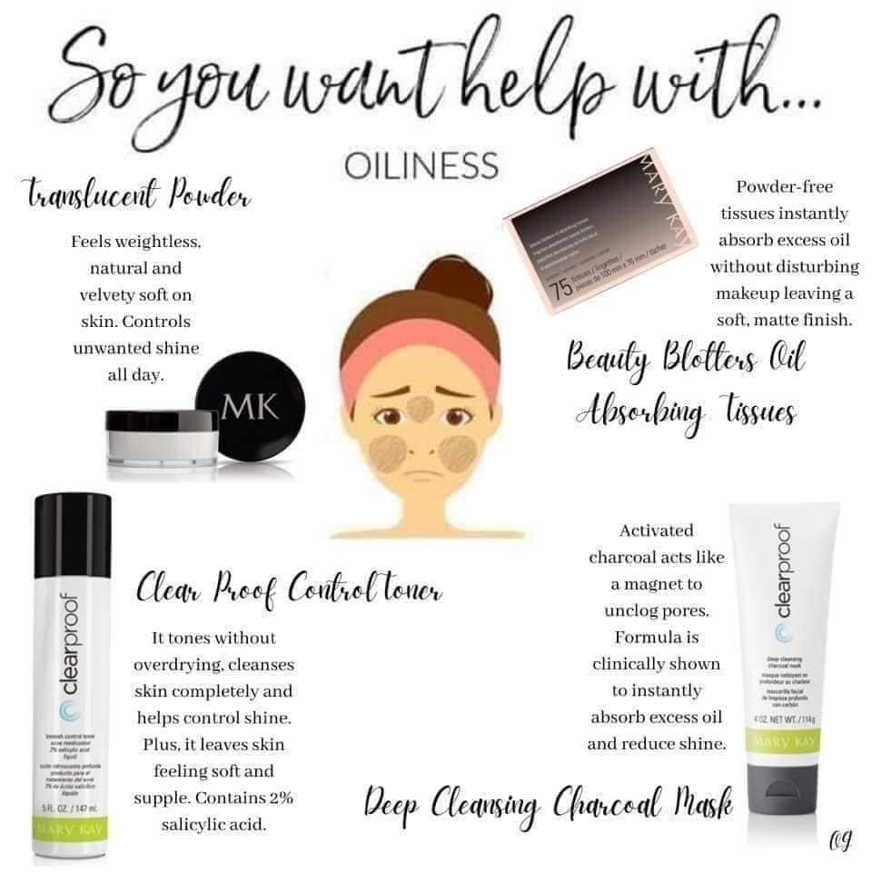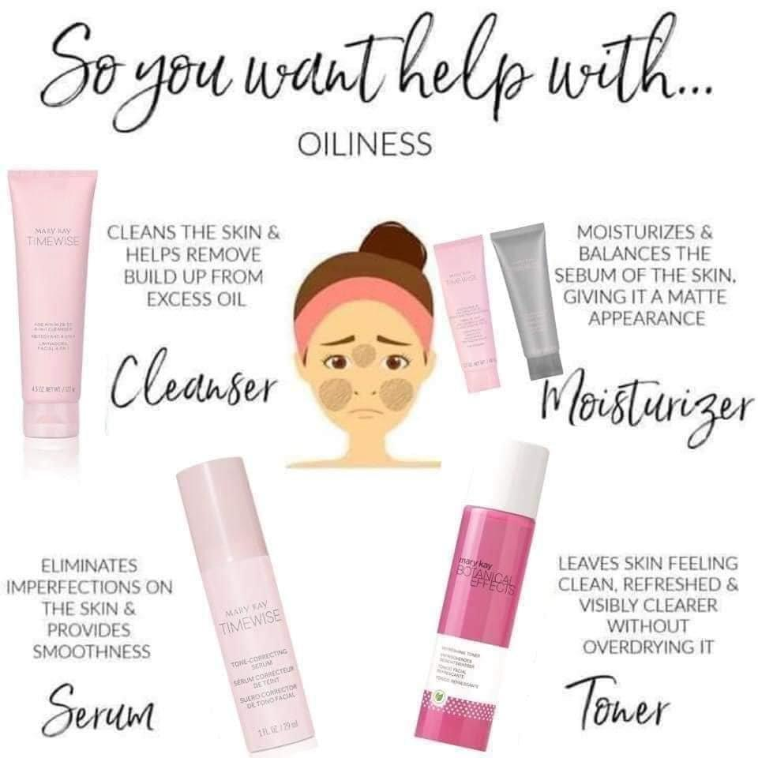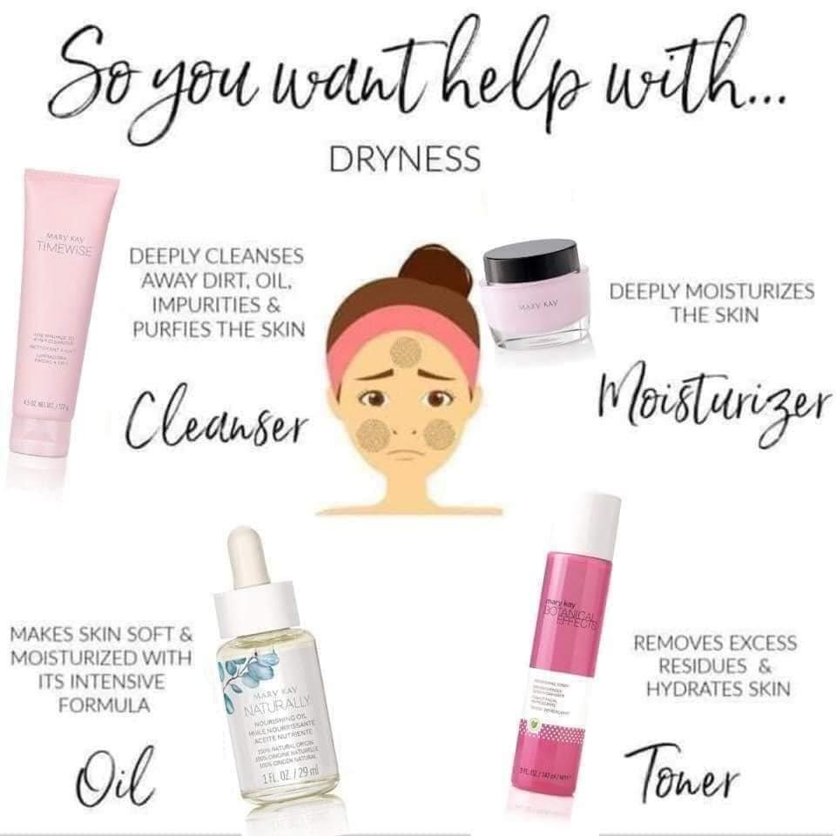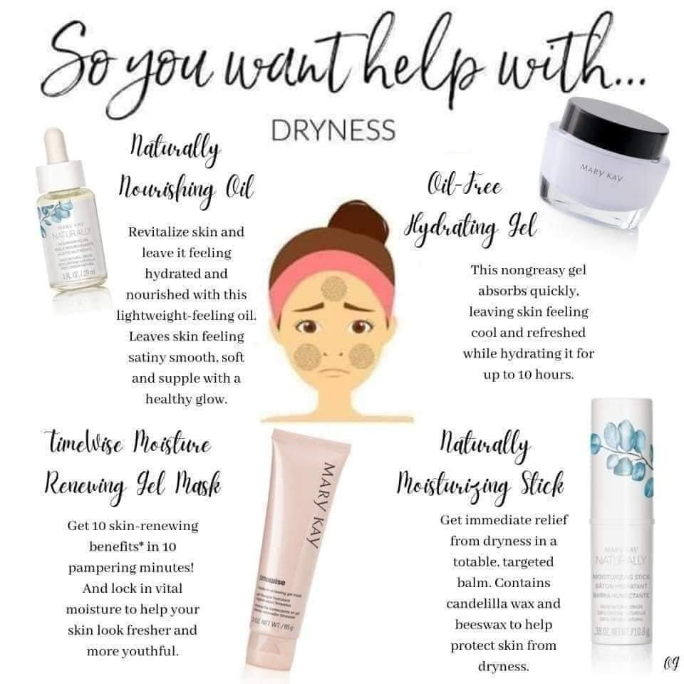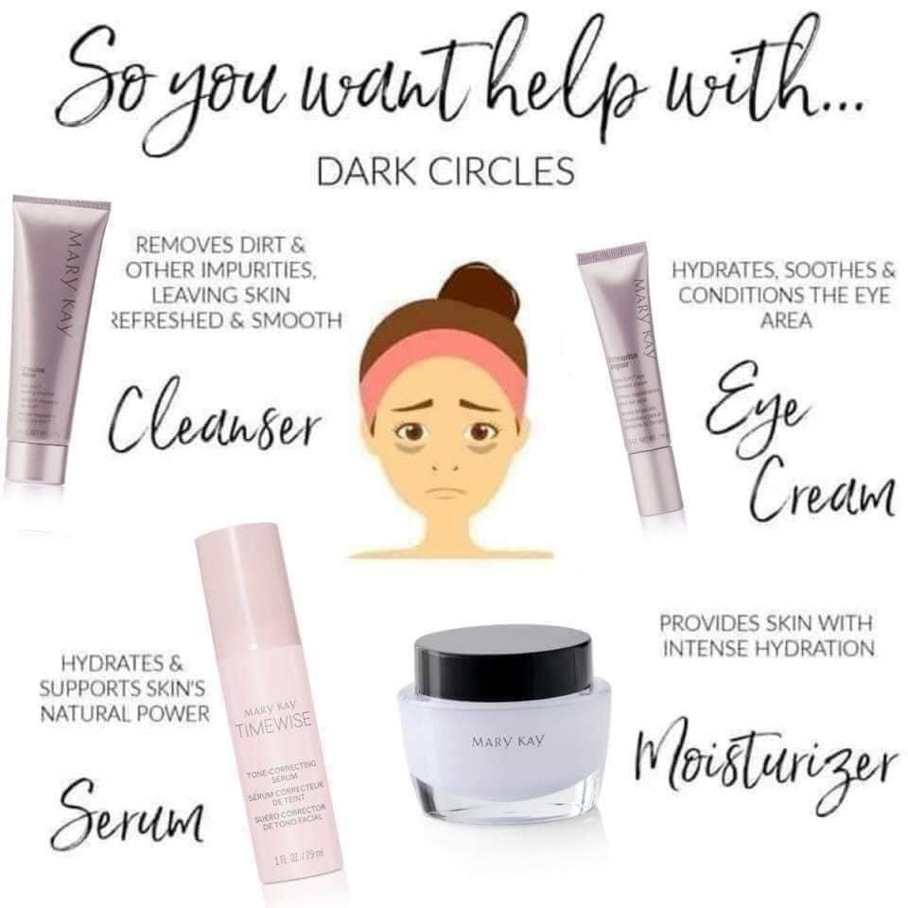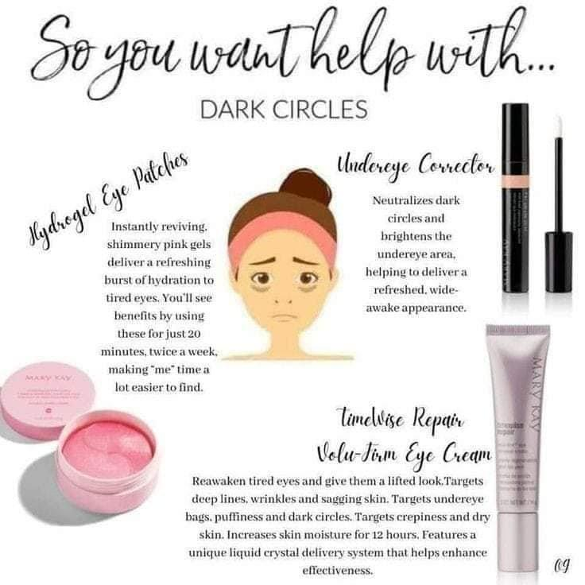
WEDNESDAY POST #3 @ 1:00pm (MAKE SURE YOU HAVE THE MOST RECENT ROLL-UP SHEET FOR YOUR GRAPHIC)
Here's a sneak-peak at some sales before I go LIVE at <TIME> today! Please reach out with any questions!!
Any sets for $99
Any sets for $199
Any sets for $299
Any sets for $399
Any sets for $499 and receive the roll-up bag ($36) for FREE!
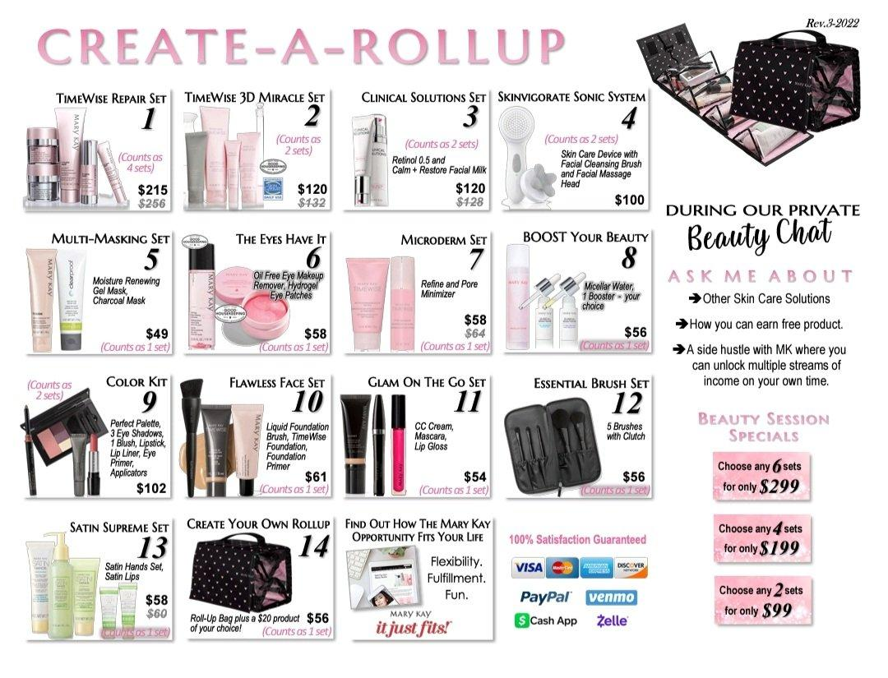

WEDNESDAY POST #4 @ 5:00pm
Here is a great way to help support your hostess!! Each event booked helps her earn more rewards!!
If you want FREE and discounted products, schedule your Facebook event with me!!
Don't like Facebook that much... Join me with some of your friends via zoom!!
<HOSTESS>, please comment below with your review on hosting a Mary Kay event!
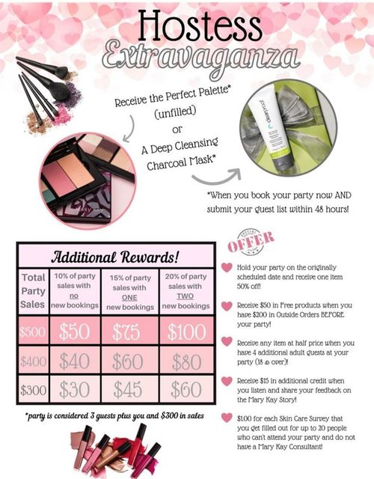
WEDNESDAY POST #5 @ 7:30pm
Don't forget to fill out our event survey below and let us know how we did!!
Also, each person that fills out the survey will be entered into a monthly cash drawing!
https://forms.gle/uZ1mZL5aZZfcKdqSA
Comment below when yours is complete!

THURSDAY POST #1 @ 10:00am
Here is a breakdown of the sales again, along with my website. Please reach out with any questions! If you are interested in the bundles on this sheet, they are not listed on the website, but I can write up an order form for you
Any sets for $99
Any sets for $199
Any sets for $299
Any sets for $399
Any sets for $499 and receive the roll-up bag ($36) for FREE!
Please message me if you'd like to take advantage of these amazing deals! I can also customize this to fit your needs!
<ADD WEBSITE HERE>
THURSDAY POST #2 @ 3:00pm
JOIN MY TEAM!!
Be a part of a half million-dollar unit! We don't mess around!!
Here are the top reasons people join.
1. Extra Cash
2. Being your own boss
3. Backup plan
4. Positive community
5. Prizes and vacations
6. Cars
7.Tax Benefits!
Join for FREE! I am giving away a FREE starter kit to the first person from this group who decides to join my team!
(You also receive a personalized Launch event Done 100% by me and you keep ALL the sales and bookings!!!)
You can't beat that!!

THURSDAY POST #3 @ 7:00pm
One day left!! Party closes Friday night!!
Let's get <HOSTESS> all the hostess credits and freebies that she deserves!!
Private message me your orders and/or questions or register and order on my website!
Thank you all from the bottom of a very grateful !
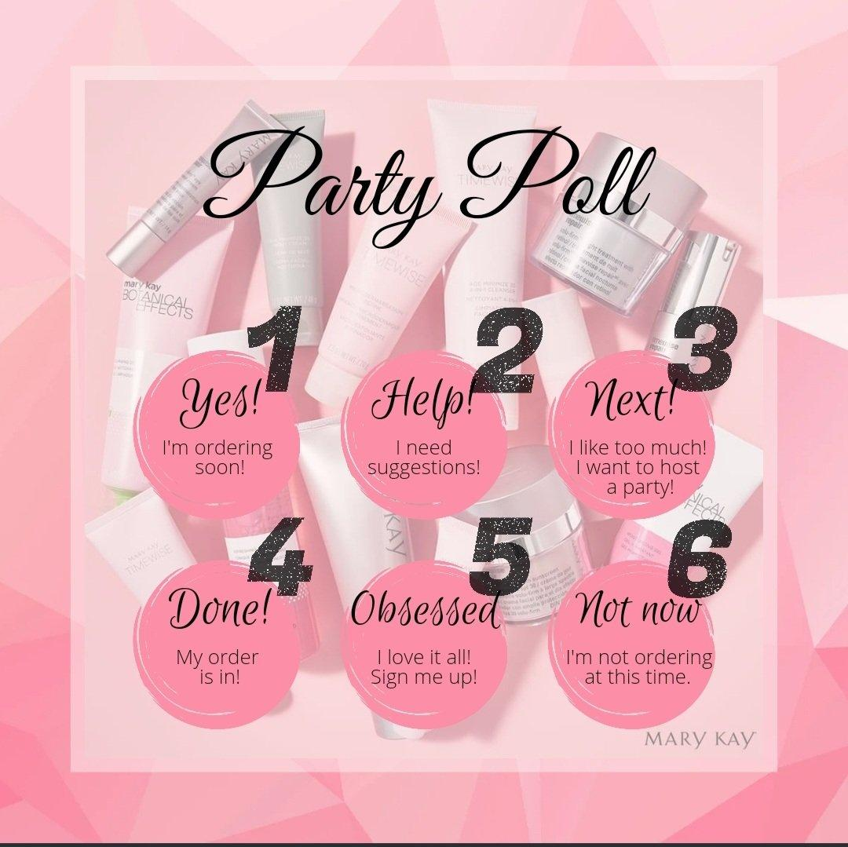

FRIDAY POST #1 @ 9:00am
Good Morning and Happy Friday Ladies!!
Quick reminder: <HOSTESS>'s event closes tonight!
If you're planning on ordering or booking your own event, please private message me so I can make sure to get you in my calendar as soon as possible!!
Reminder
If you won a coupon, it will expire at the close of the event tonight
I'd love to add some samples to your order! Comment below and let me know what you'd like to try!
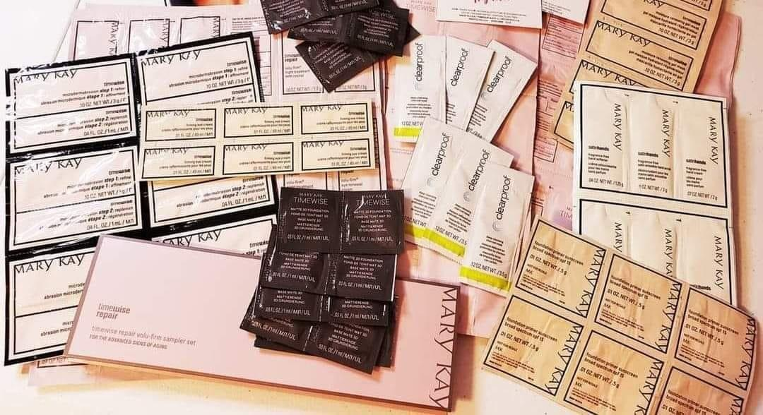

FRIDAY POST #2 @ 2:00pm
You Ladies were AWESOME!
I'm not ready to say goodbye....so let's stay in touch!
Join my Private Mary Kay Facebook Group! See below all that you get access too!!
Flash sales and discounts
New Products
Beauty tips, tricks and trends
Special Events
Positive and uplifting community.
I hope to see you in there!
<ADD LINK TO YOUR FACEBOOK VIP GROUP>

FRIDAY POST #3 @ 5:00pm
Ladies!! Who can help a girl out??
<HOSTESS> is only SO close to hitting the next level of rewards!!
All we need is one more person to book their own event to help her out!! Who would LOVE some free and discounted products!! It's so easy! Who can help us out???
FRIDAY POST #4 @ 7:00pm
Only a few more hours left!! Coupons and Sales expire soon!!! Don't miss out!
Three ways to order
1. Via my website below. Be sure to check out as a registered customer (so important)!! I'll be able to throw in freebies and apply your discounts!! This is the best option if you want to pay with a credit/debit card.
2. Mary Kay app (also please choose me as your MK consultant )
3. Via messenger. We can chat about your order, and I can help make suggestions! This is the best option if you want to pay via Venmo.
Website link:
<ADD WEBSITE LINK HERE>

LAST DAY OF PARTY (SATURDAY MORNING). YOU CAN ALSO POST THAT YOU ARE EXTENDING THE PARTY THROUGH THE WEEKEND IF YOU NEED MORE BOOKINGS OR SALES FROM THE EVENT
That's a wrap ladies! I wanted to thank you for all your participation throughout <HOSTESS>'s event and thank you for supporting me and my small business. You have helped support my family as well as the Mary Kay Foundation. Your purchases are going to help causes such as cancer research for women's cancers, domestic violence, women's shelters across the United States AND Human Trafficking!
Thank you from the bottom of a very grateful heart

Pictures you can use for extra games or incentive posts
